**AWS – Amazon Web Service**

Amazon S3 – Amazon Simple Storage Service

Amazon S3 – Object storage built to retrieve any amount of data from anywhere.

Amazon S3 stores data as objects within buckets.

An Object is a file and any metadata that describes the file. A bucket is a container for objects. To store your data in Amazon S3, you first need to create a bucket and specify a bucket name and AWS Region. Then upload your data to that bucket as objects in Amazon S3. Each object has a key (or key name), which is the unique identifier for the object within the bucket.

**Step1: Search S3**

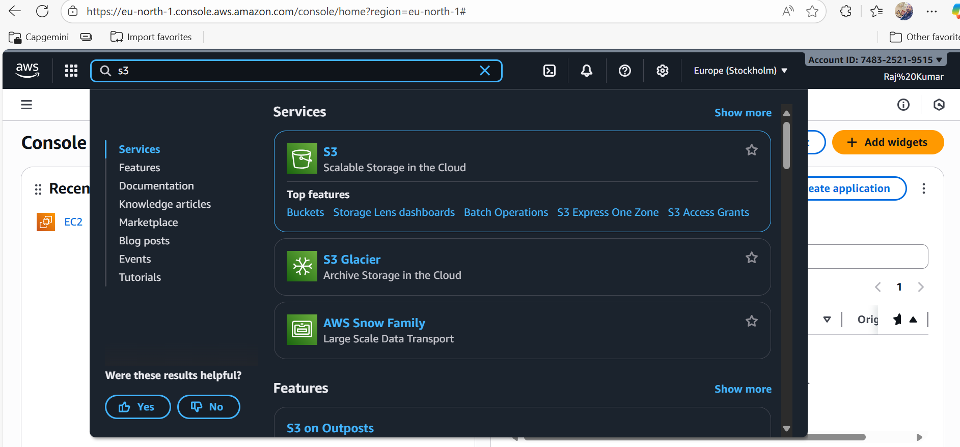

**Step2: click on Create bucket button**

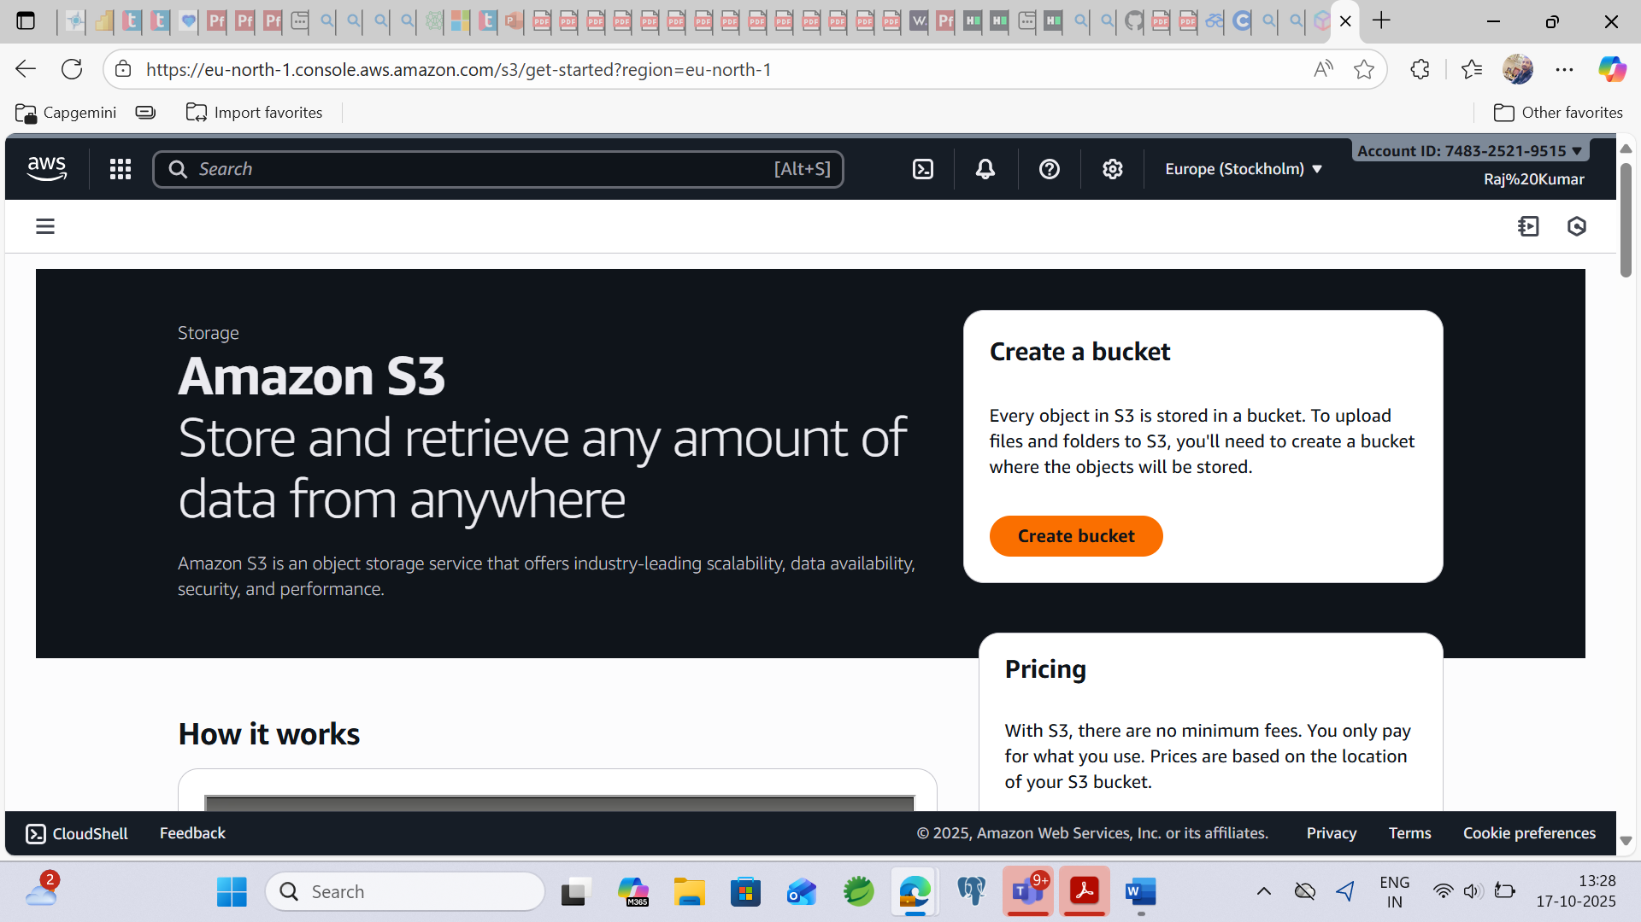

**Step3: Bucket name must be start with lowercase or number**

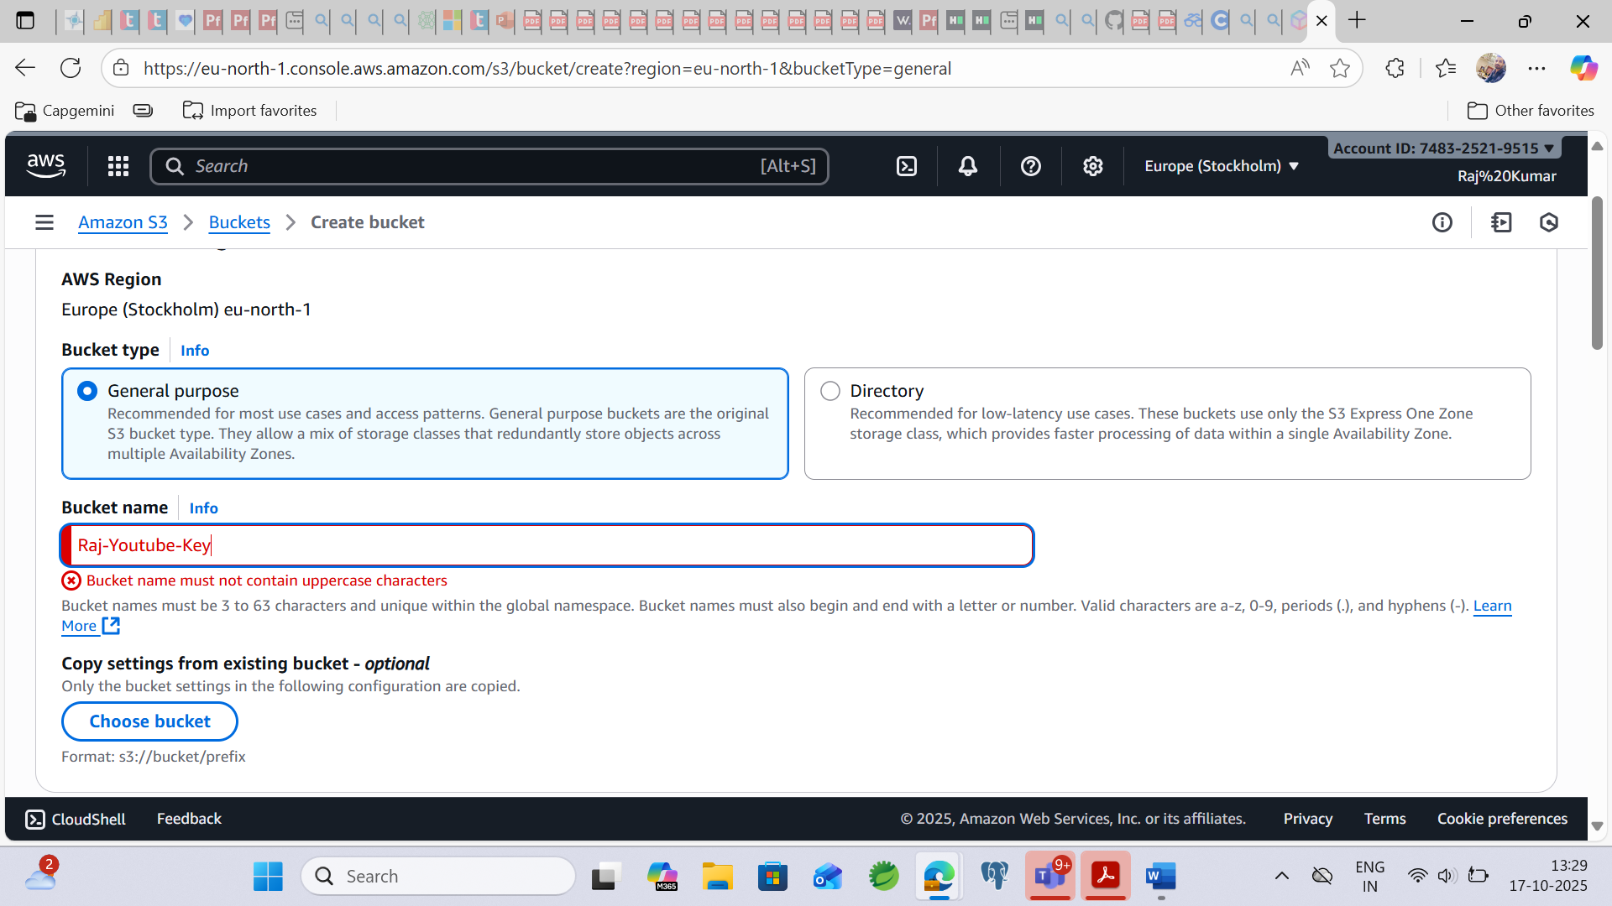

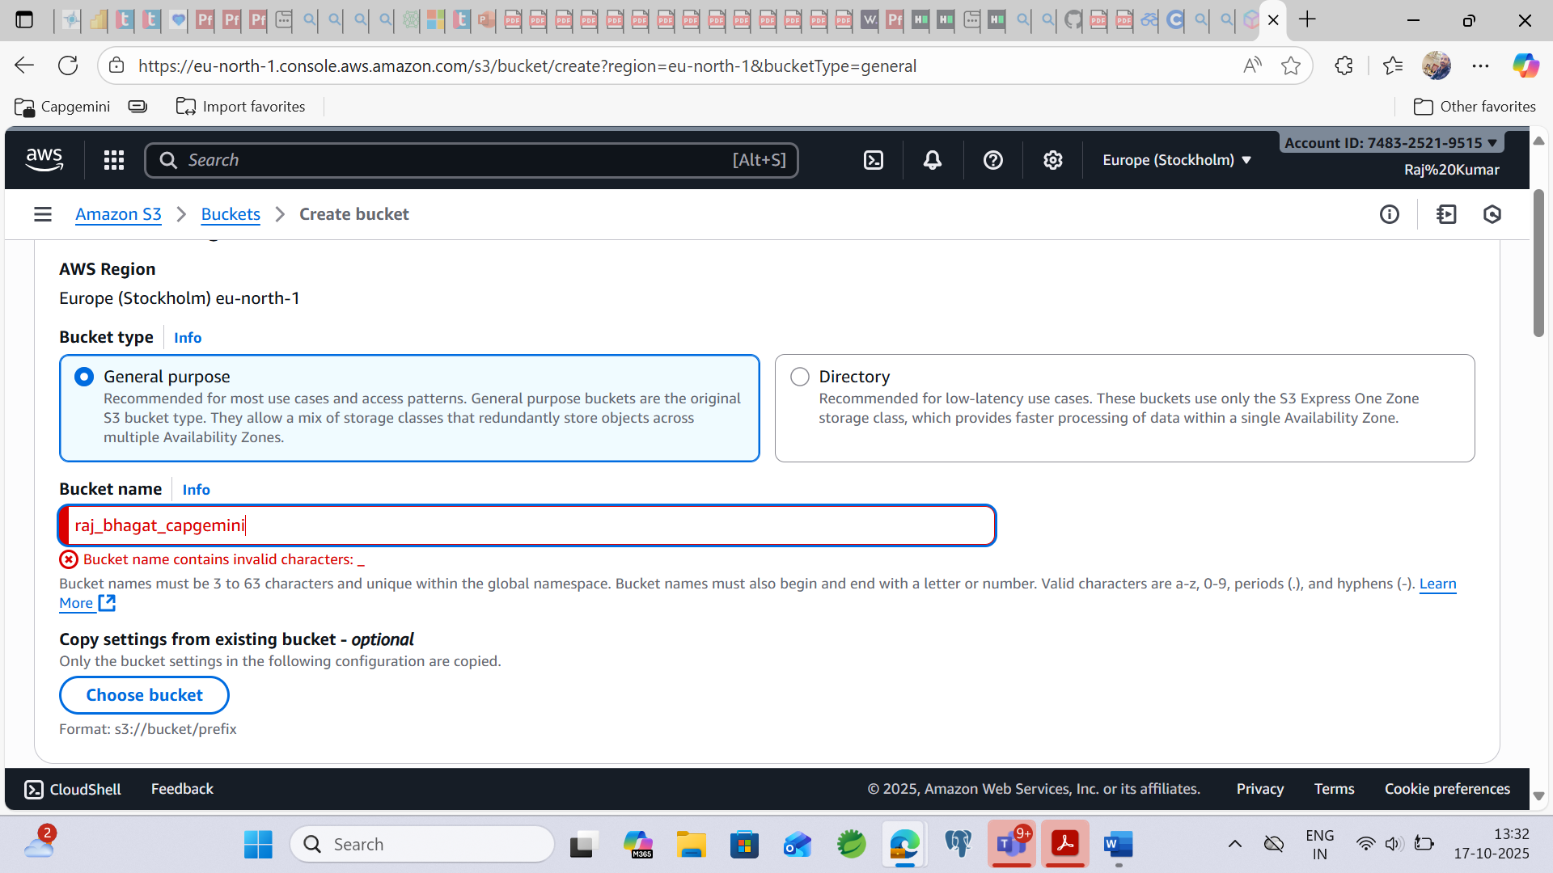

**Its will not contains large characters**  
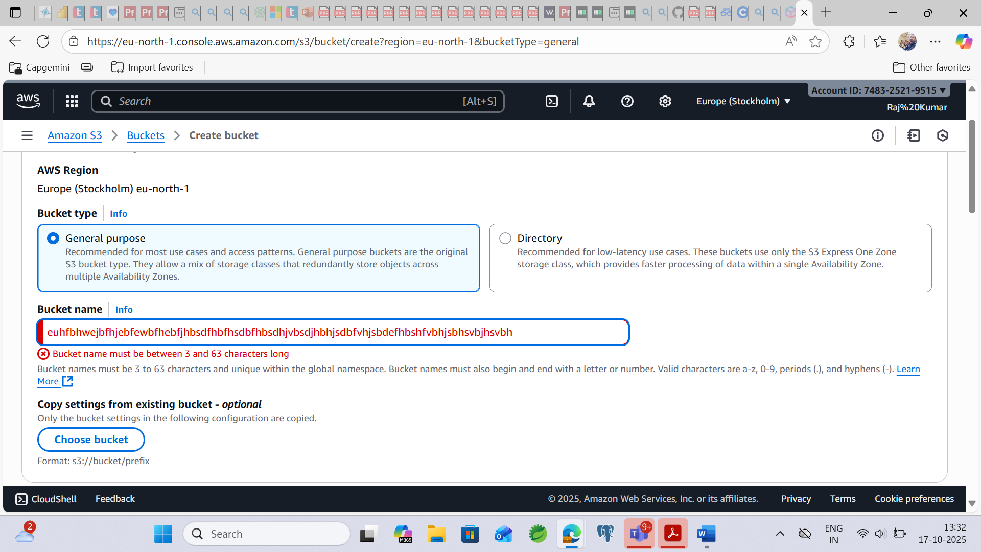

**It will not accept IP address**  
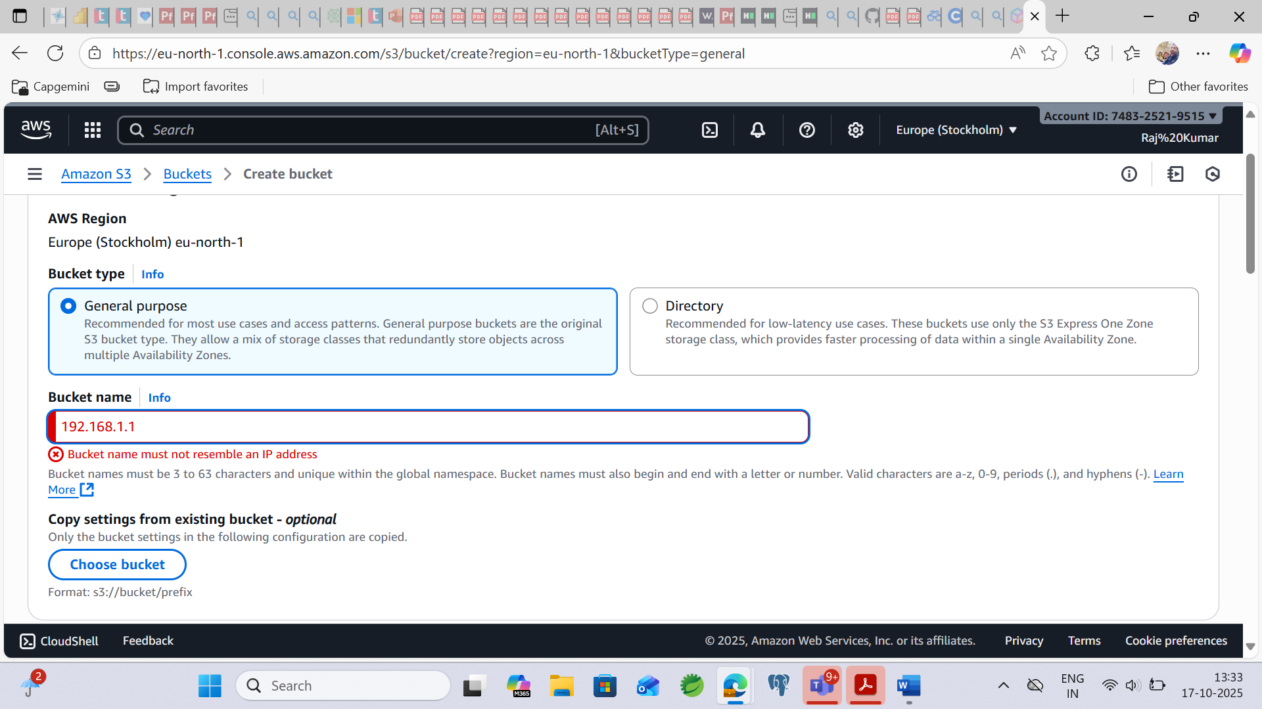  
  
**Bucket name must be start with lowercase or number**  
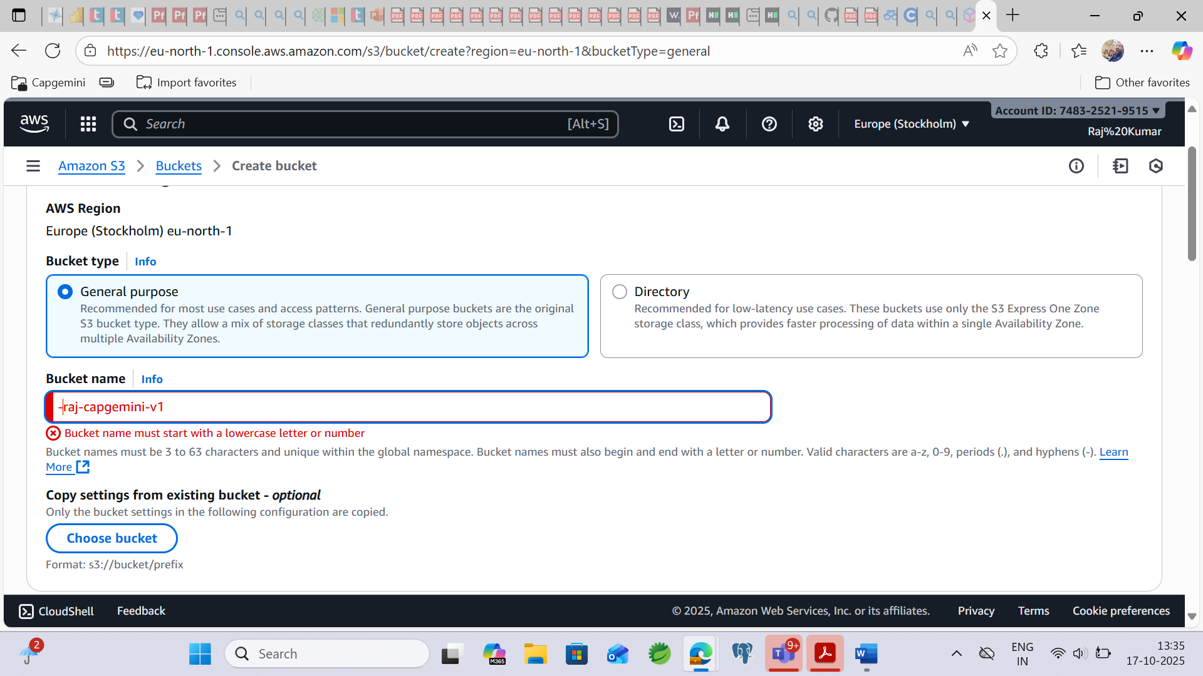**Step4: Finally We are going to create bucket…**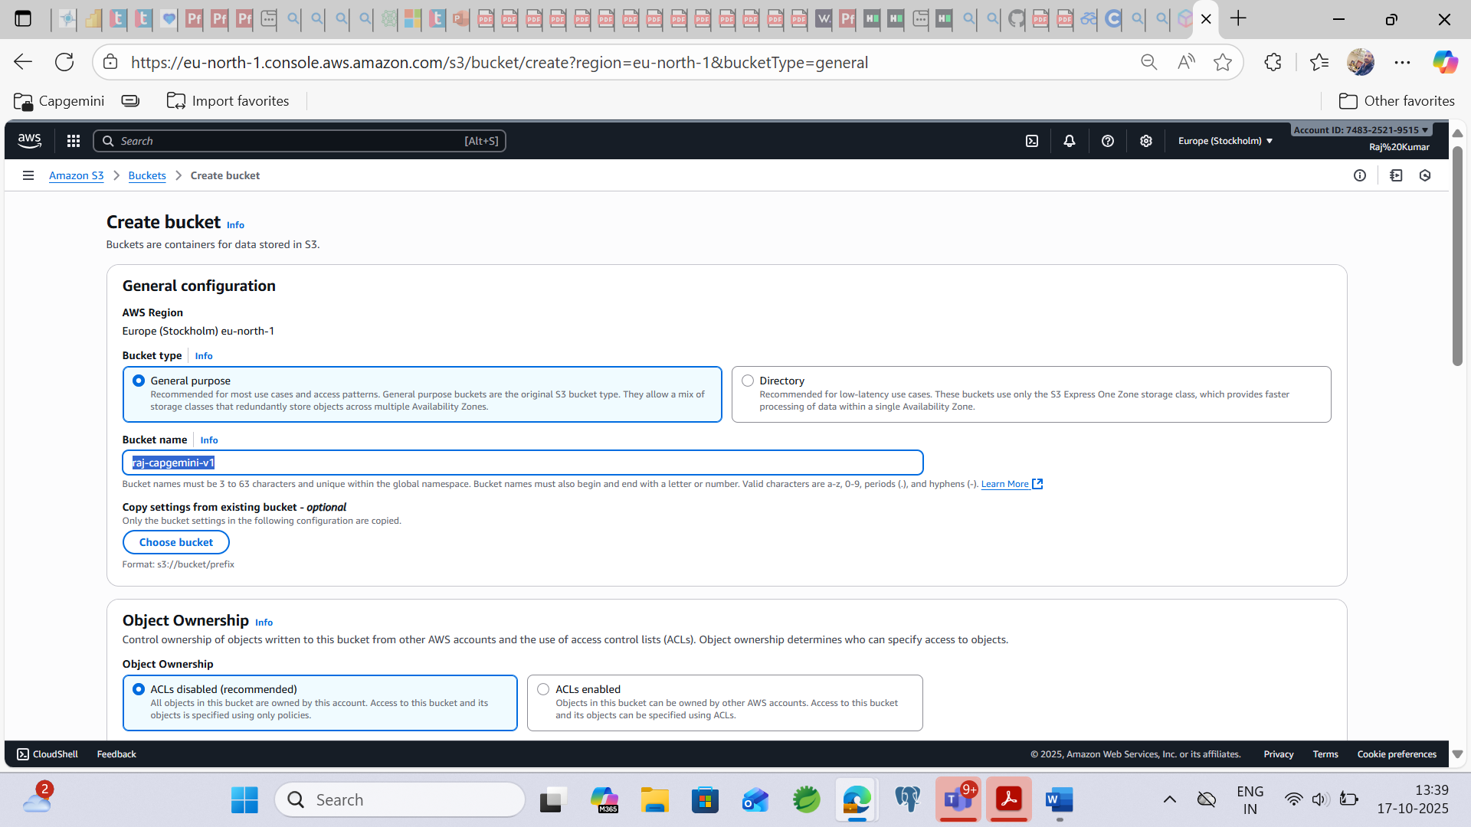

**We can access this bucket as private for now.**  
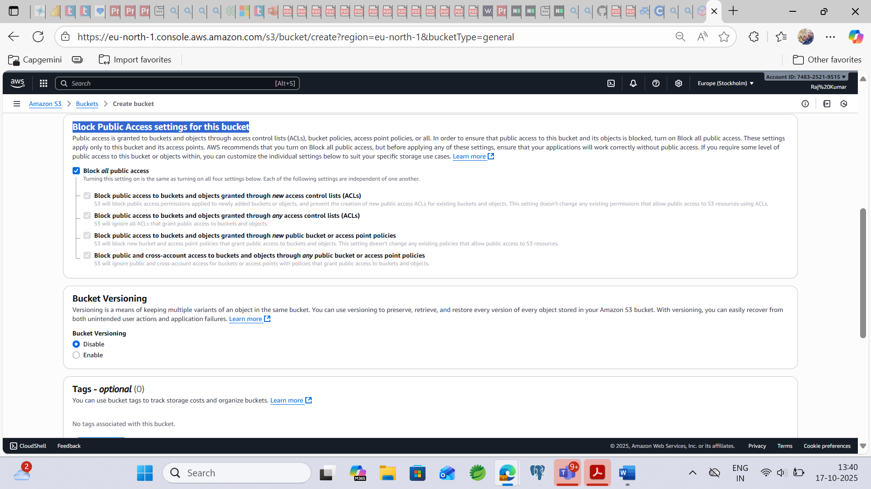  
  
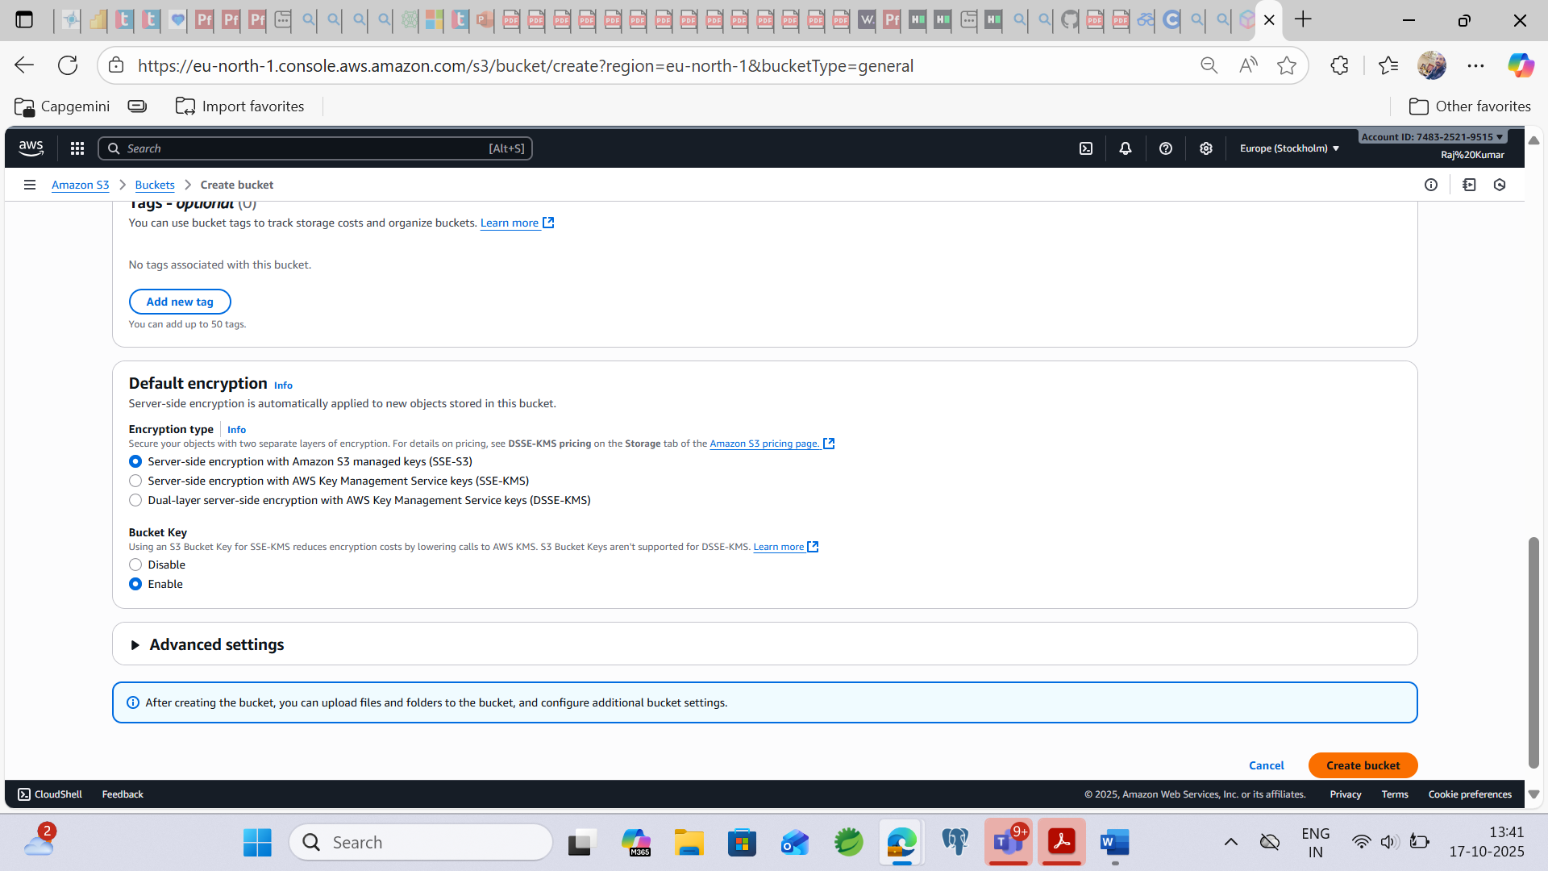  
  
**Bucket created Successfully.**  
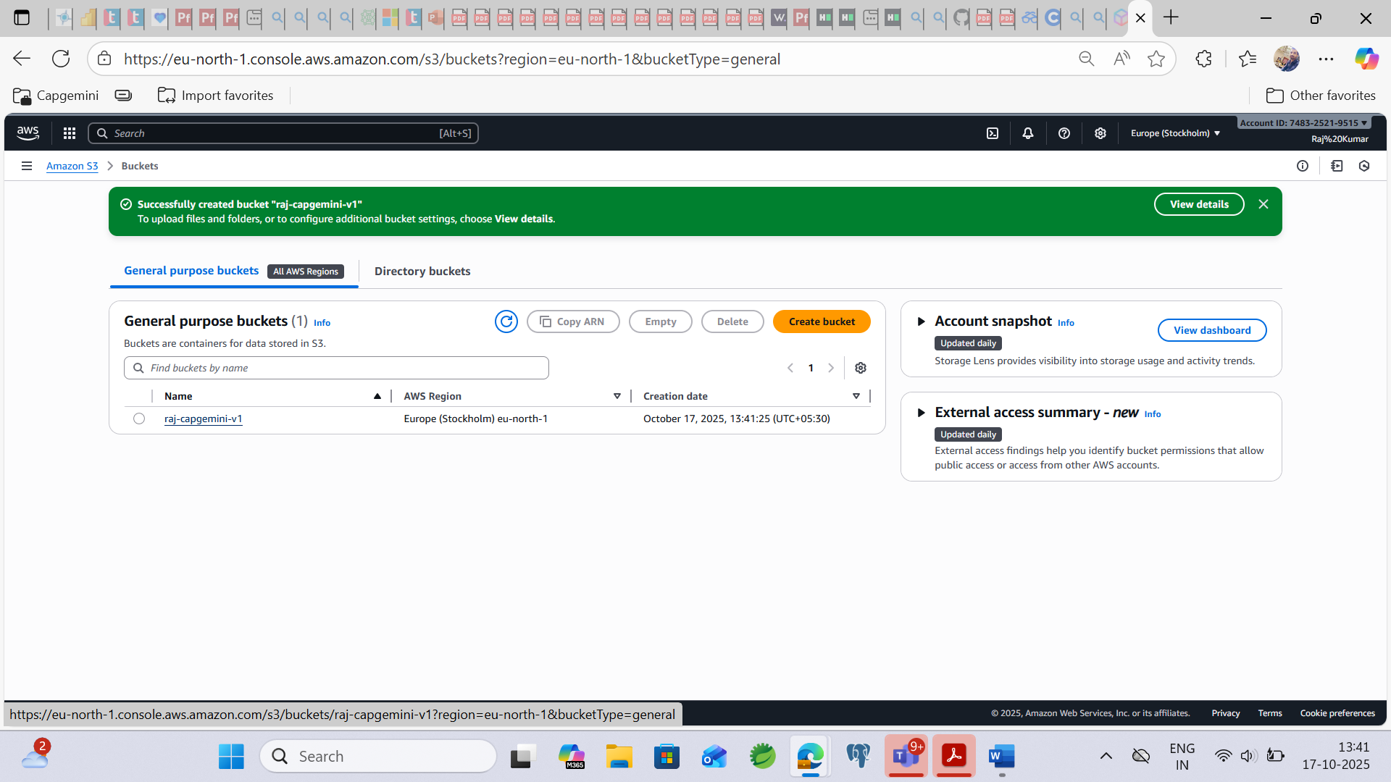

**Step5: For uploading file, Click on bucket link: – raj-capgemini-v1**

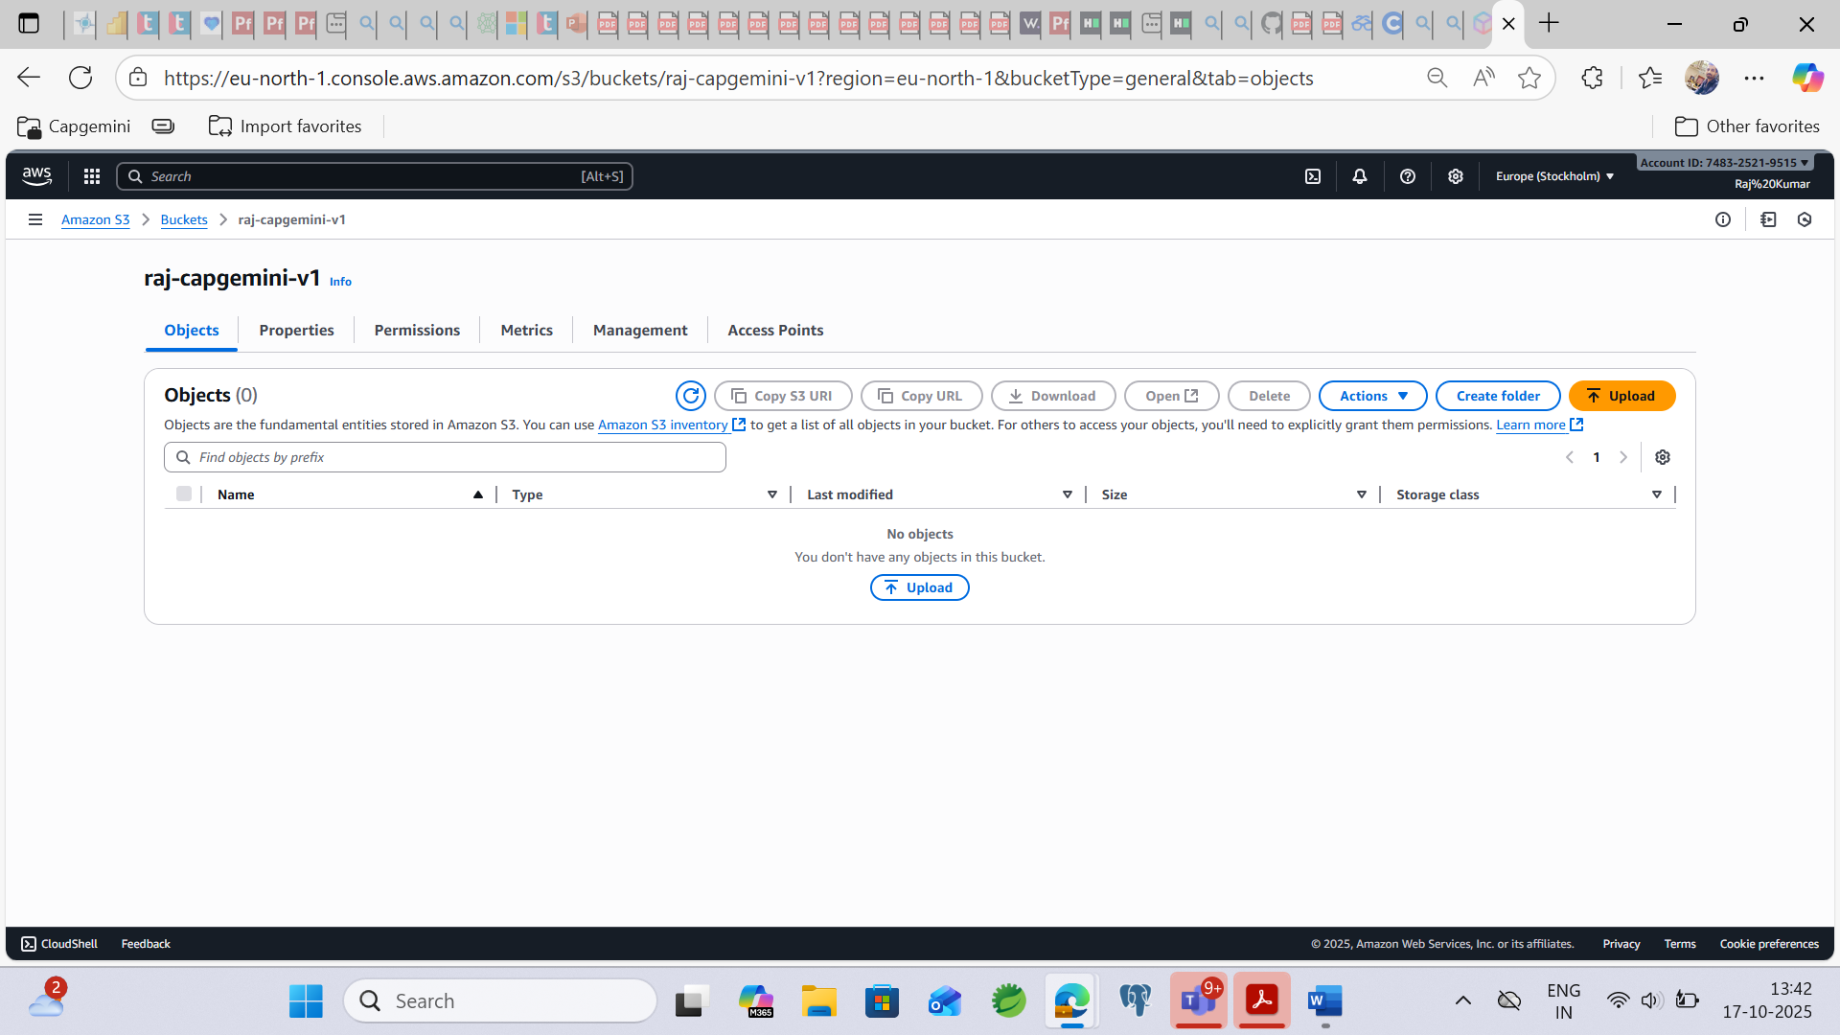  
  
**Click on upload button then click on Add files then upload your file whatever you have :-**  
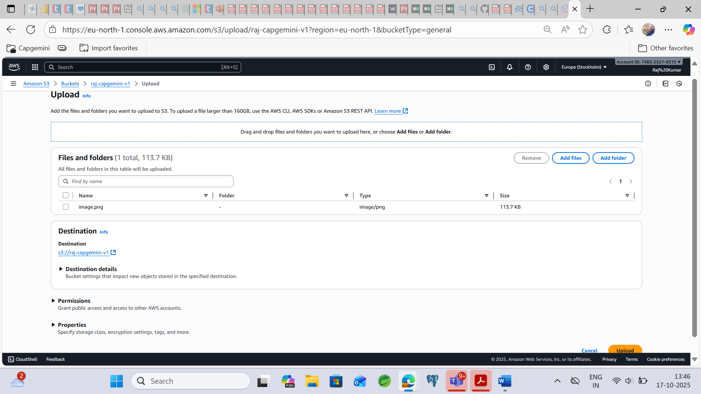

**Now click on upload button then file is uploaded successfully…**

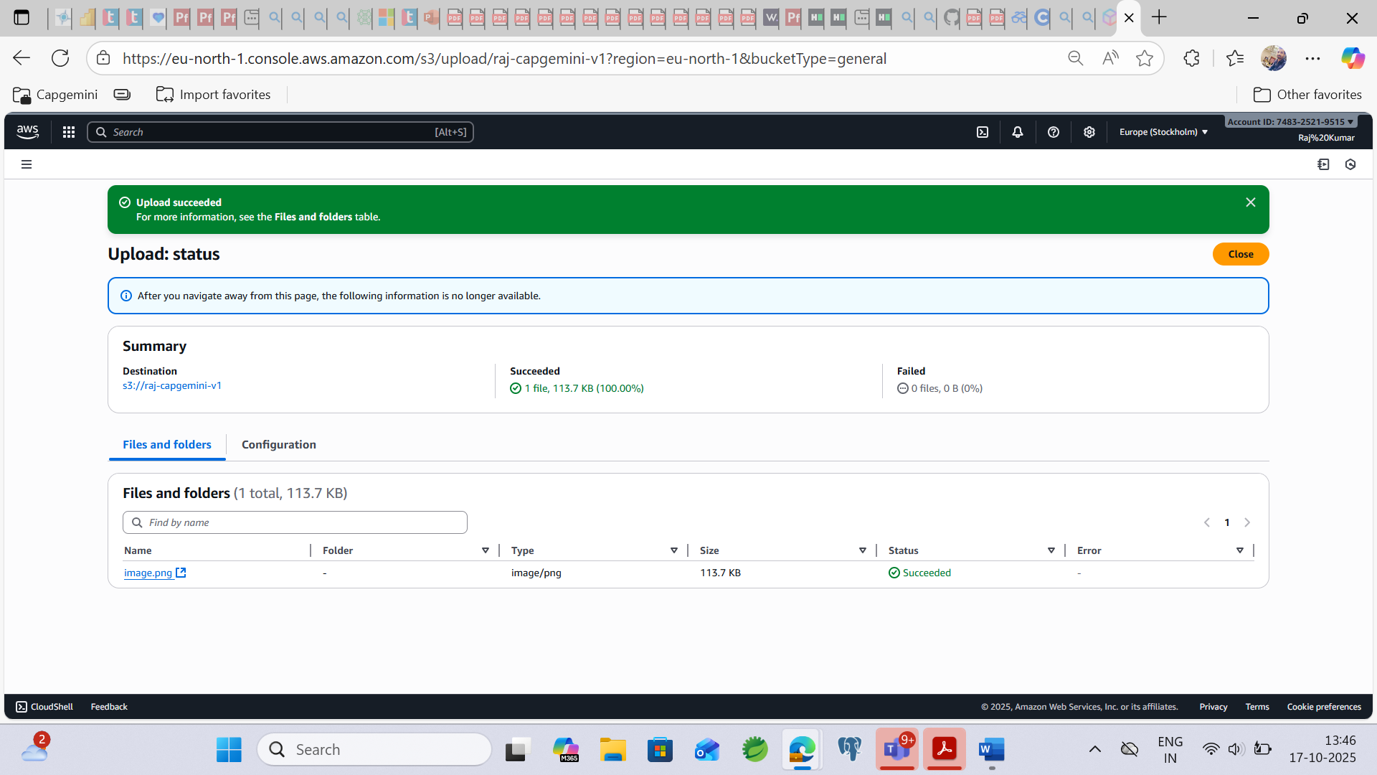

**Step6: Click the bucket link that file is called as an object.**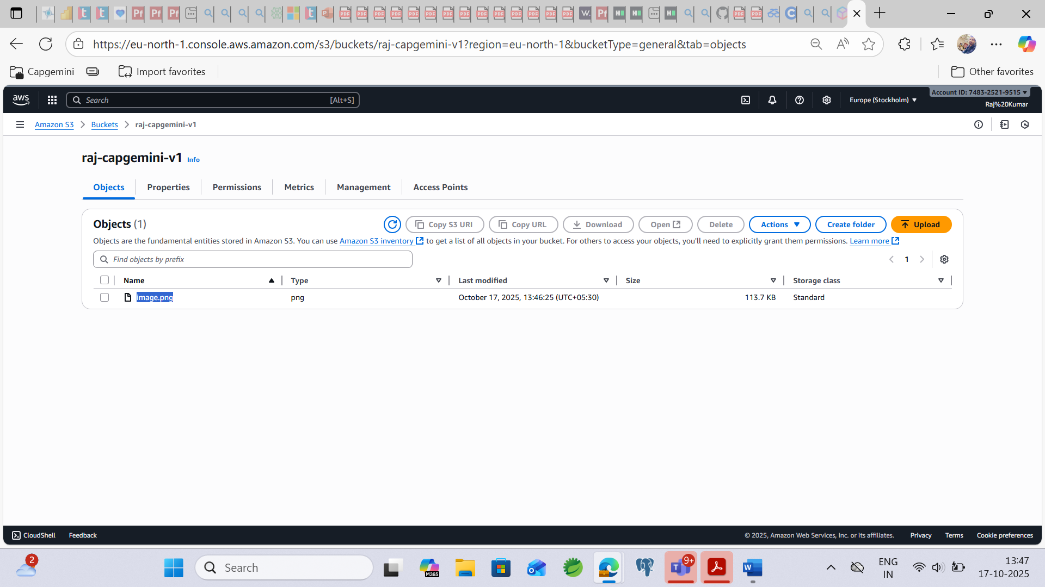

**How to access this file?**

**Step7: First need to select that file then click on Open button**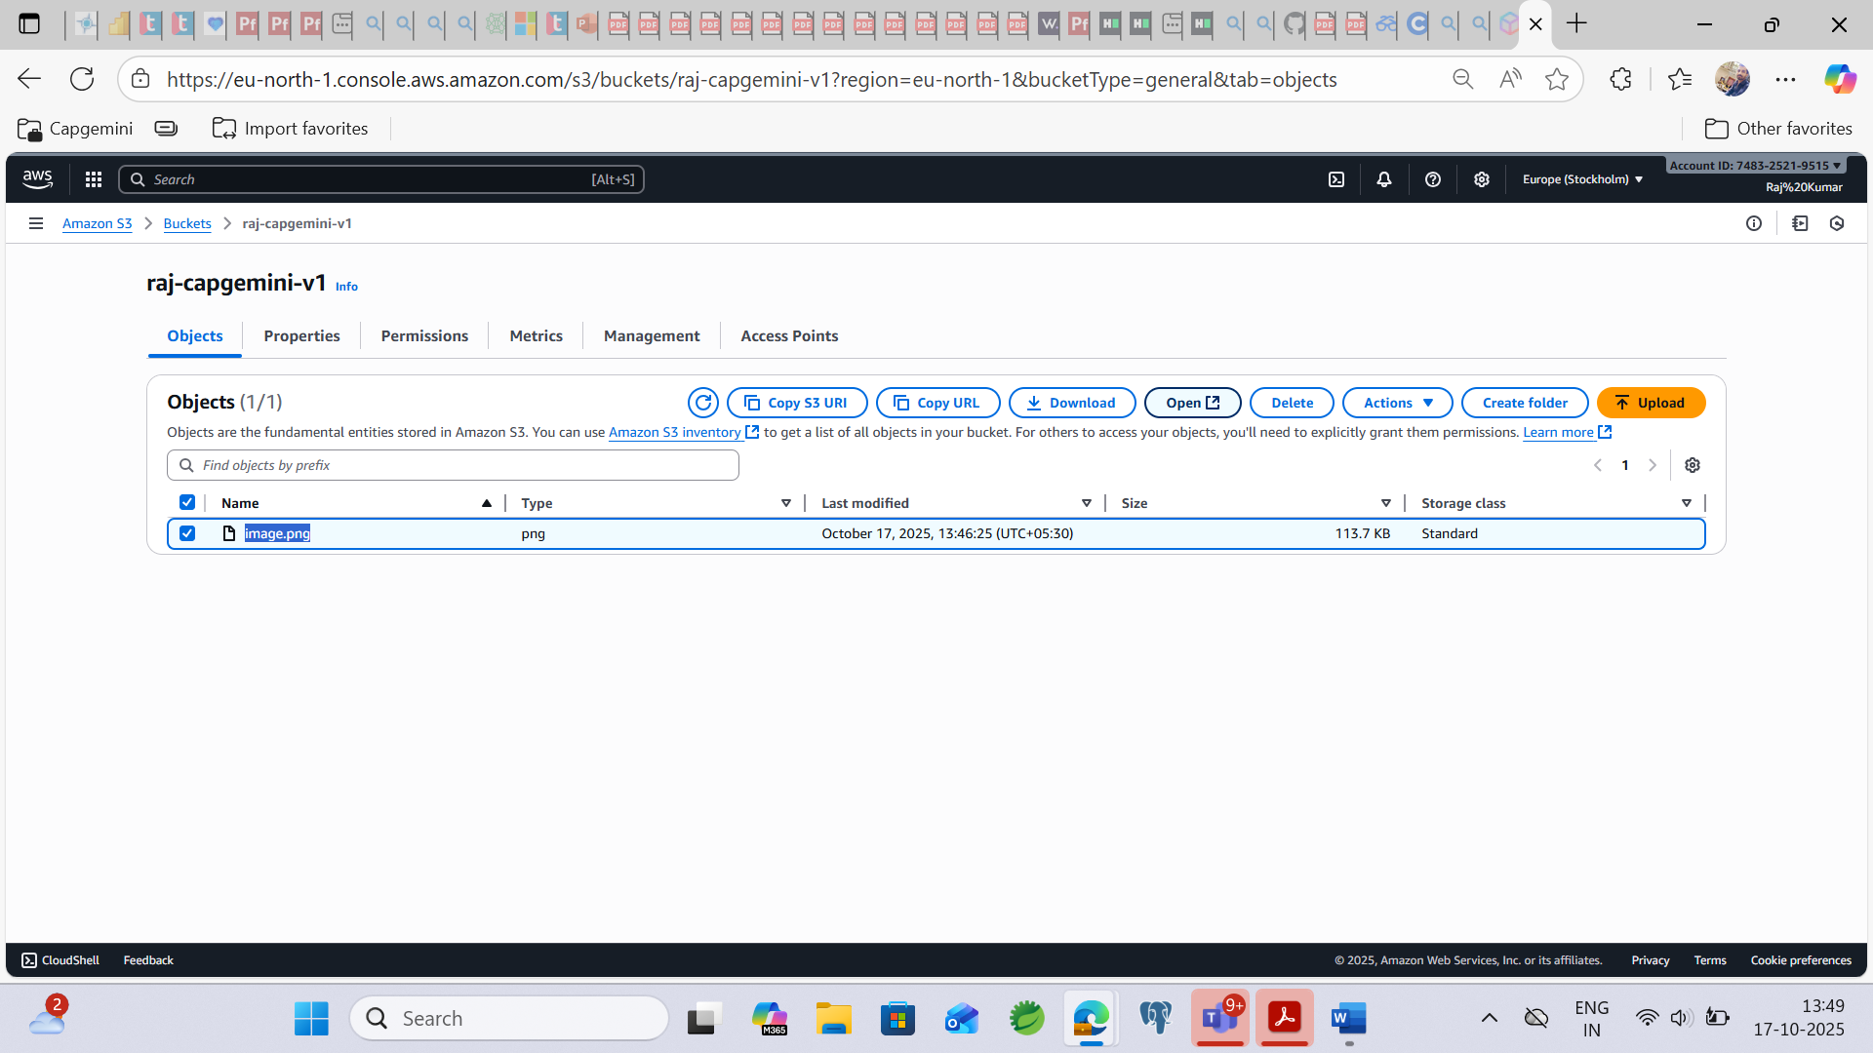

**Step8: Finally, after clicking the open button then we are getting like this.**

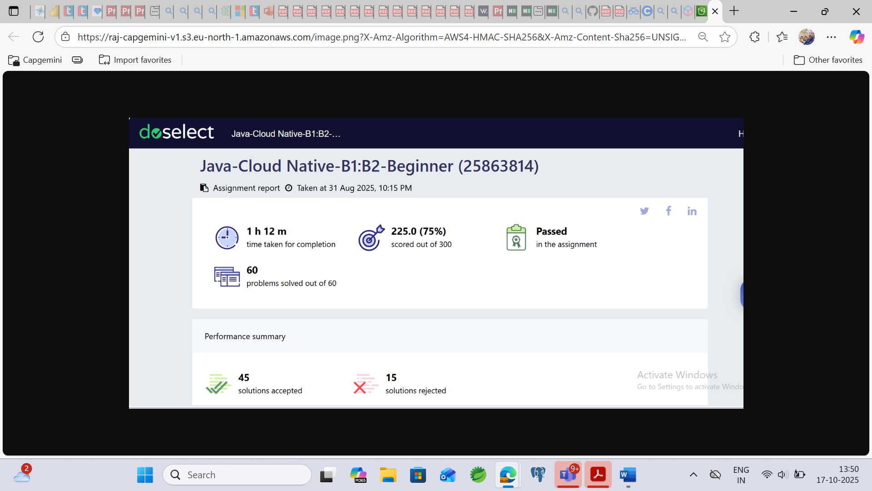

**Step9: Click the object directly.**   
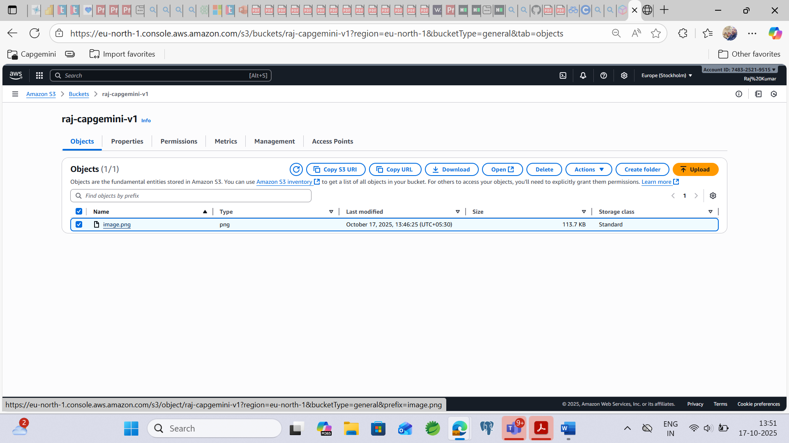

**Step10: Now copy the object URL.**

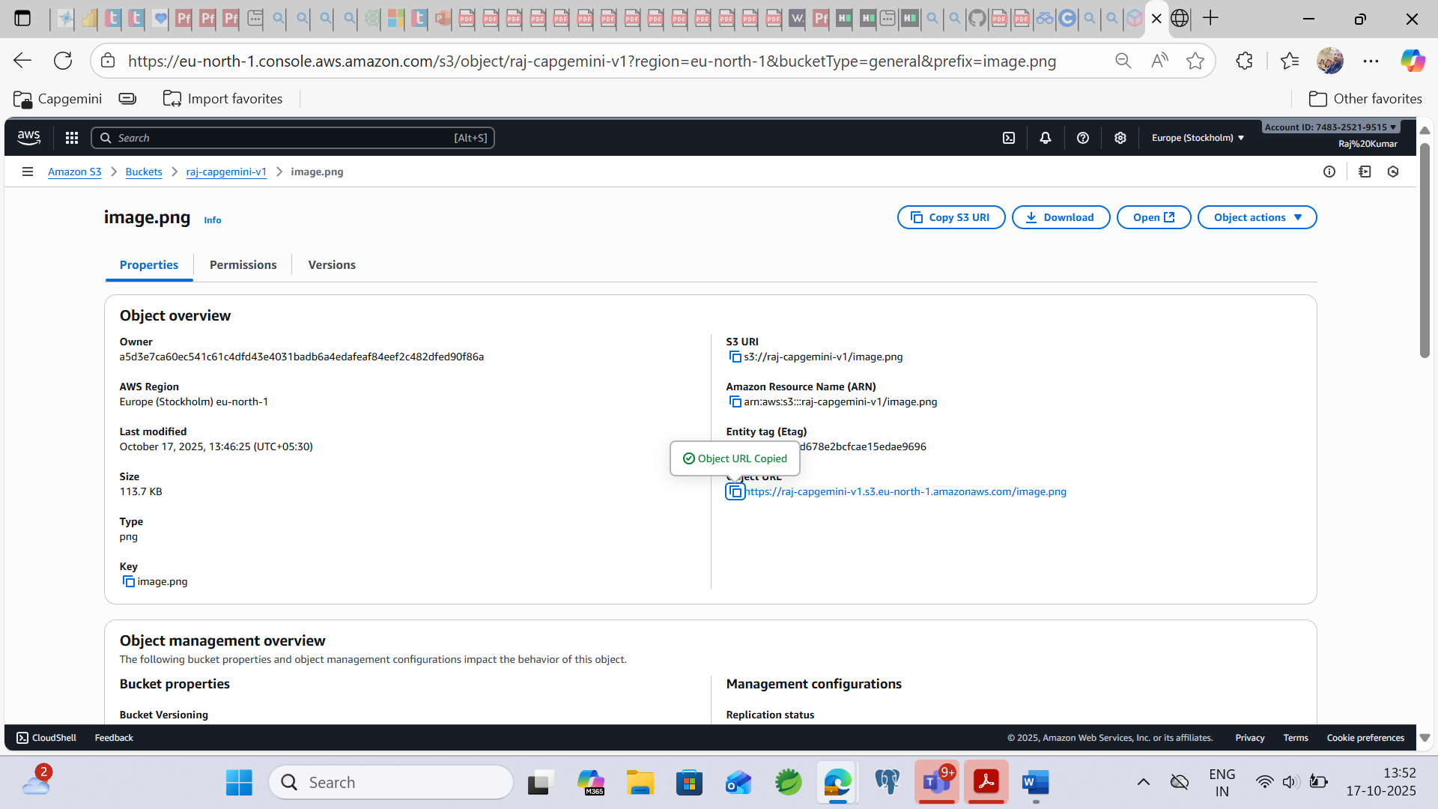

**Step11: Now we are getting error when we are accessing object URL in chrome.**  
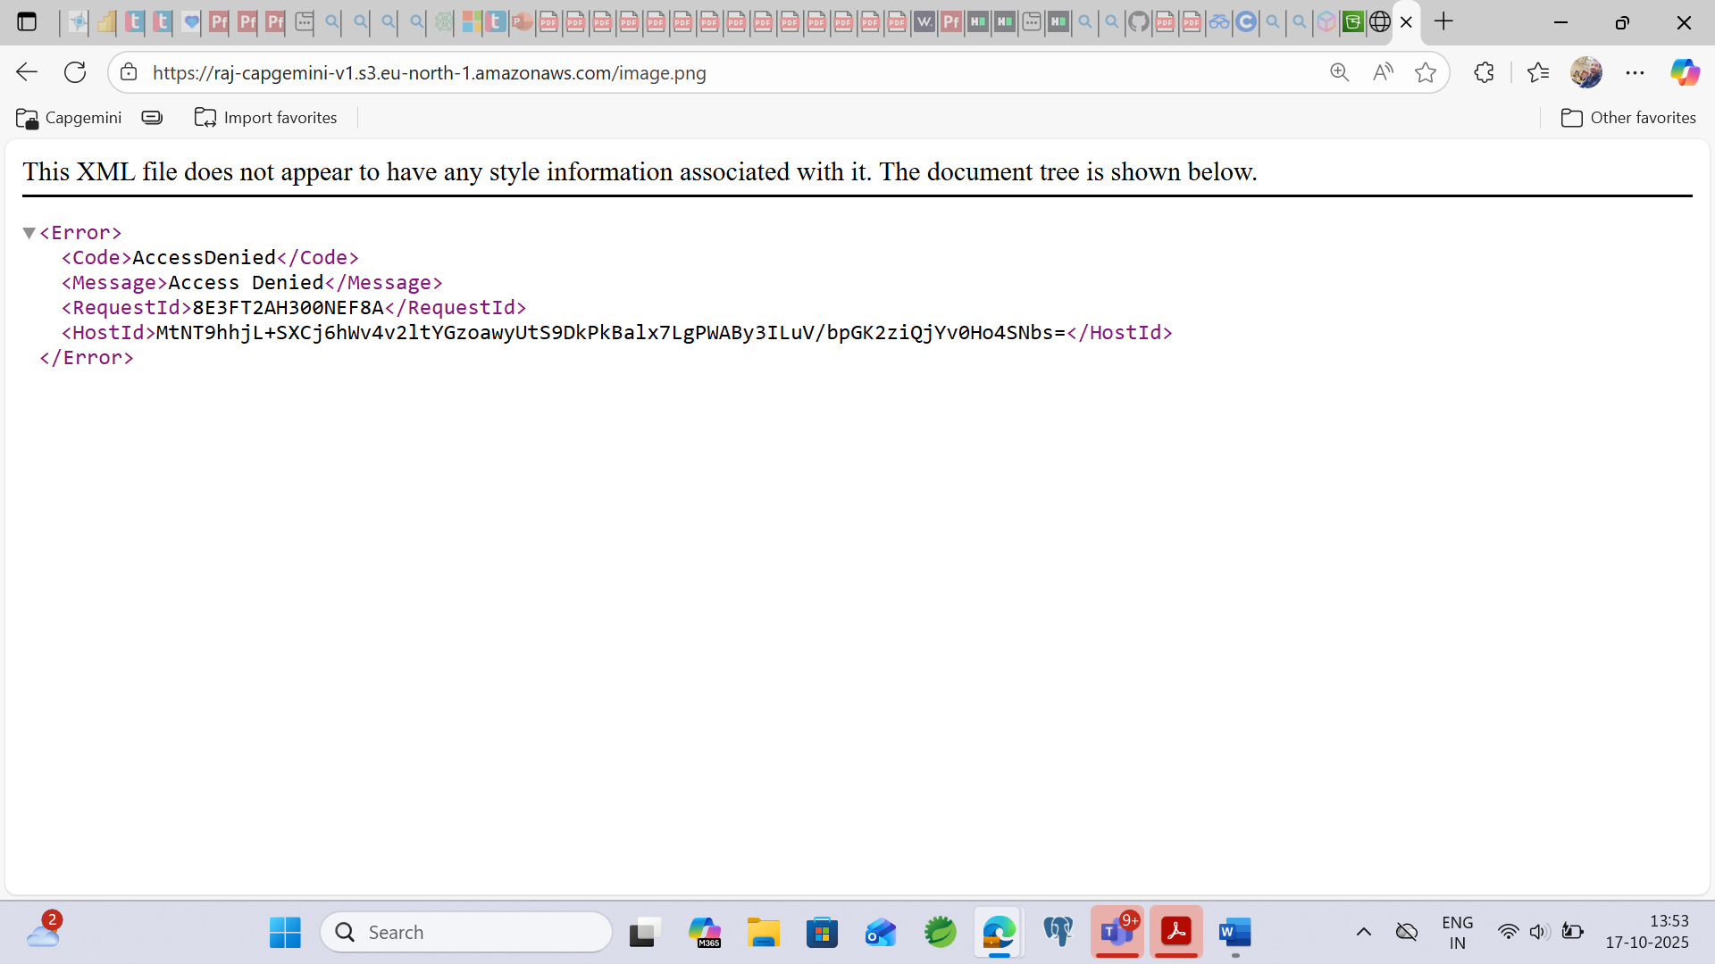

**How can we access the bucket object URL and how can we make it as public?**

**How to object URL access by publicly.**

**Step12: First Click on your bucket and then go under Permissions.**

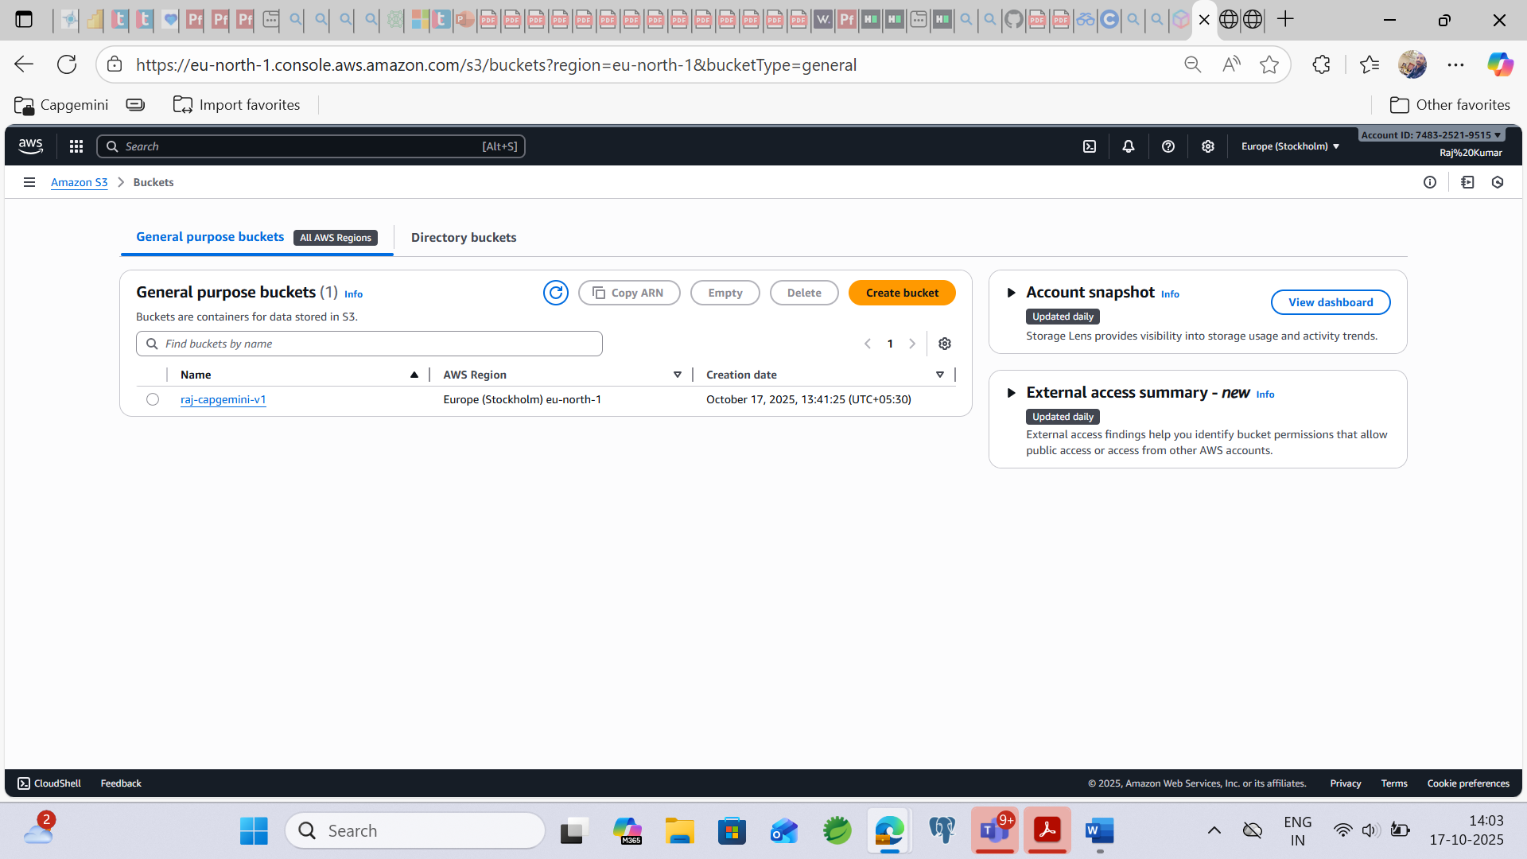

**Step13: click the Edit button for Bucket policy…**

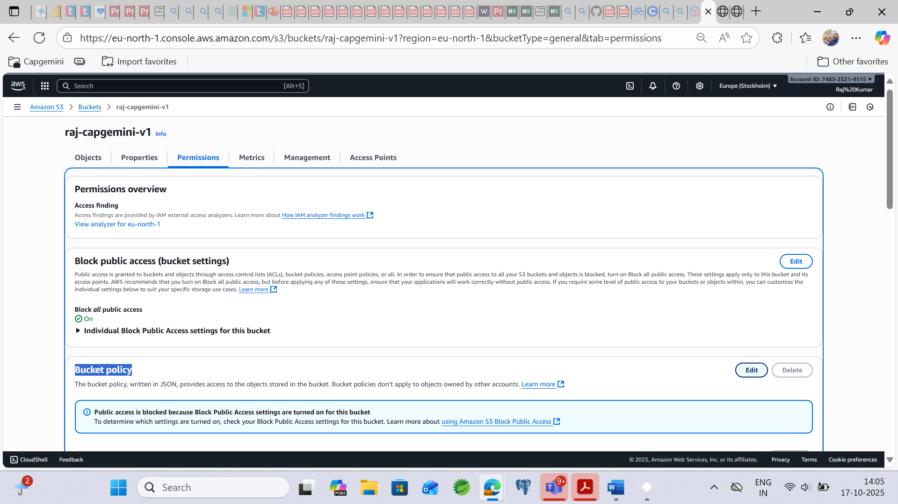

**Step14: After clicking edit button, now click on Policy generator button**  
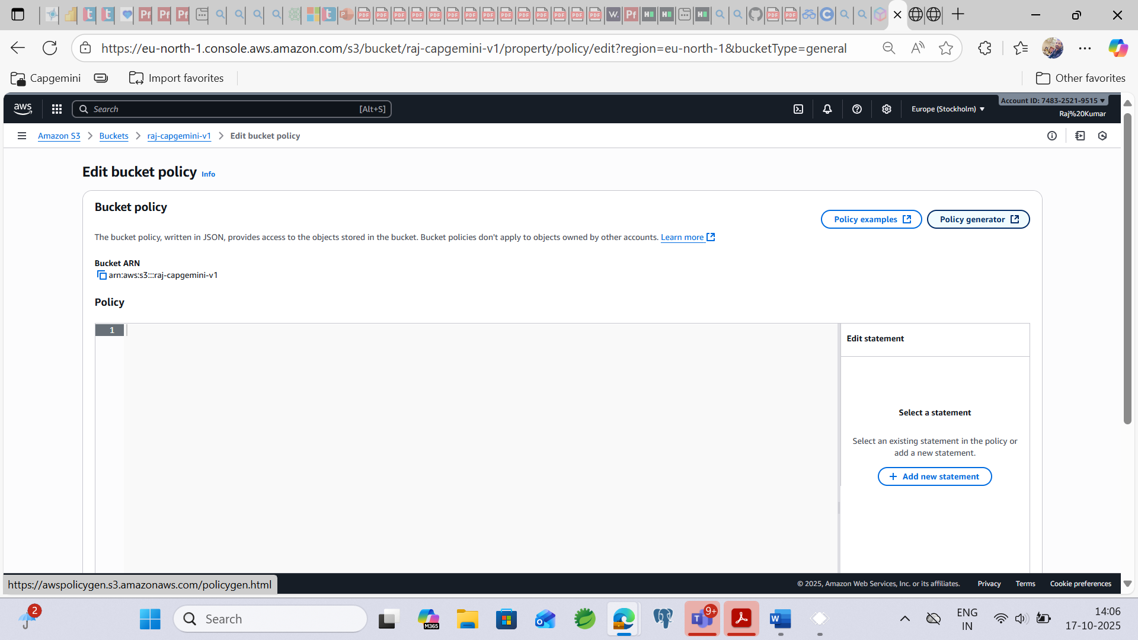

**Step15: Now need to add the field name   
Type of Policy – S3 Bucket Policy  
Effect – Allow  
Principle - * (for all we are giving access)**  
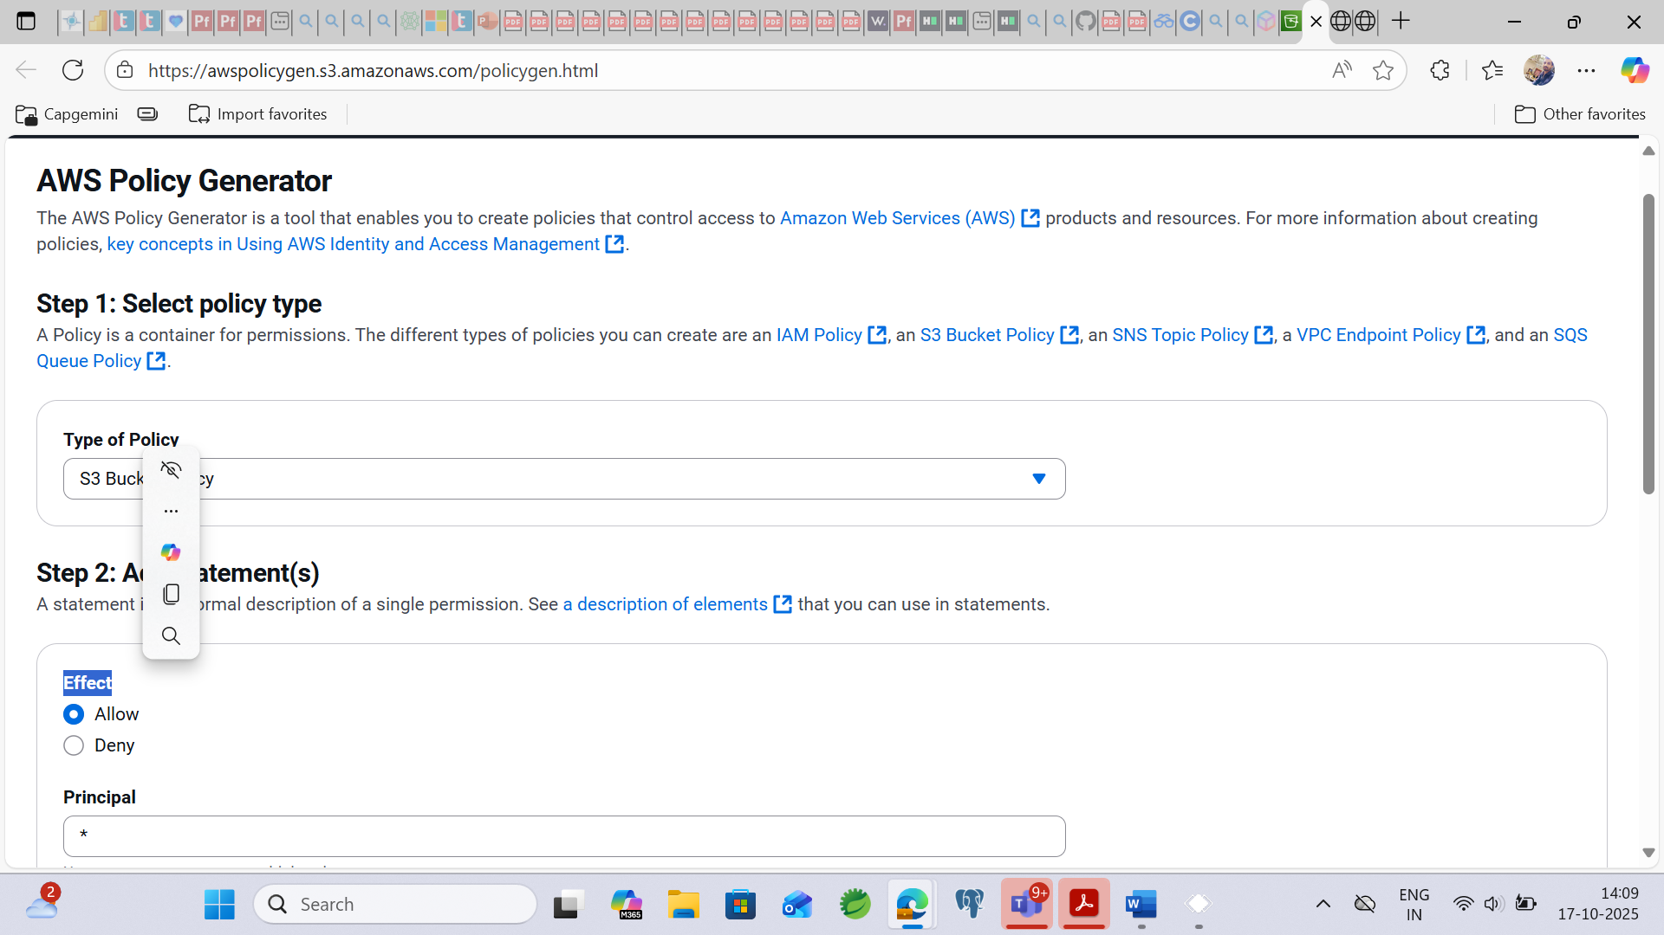

**Bucket ARN is ….**

**Get the Bucket ARN from the location i.e.** [**Amazon S3**](https://eu-north-1.console.aws.amazon.com/s3/get-started?region=eu-north-1&bucketType=general) **🡪** [**Buckets**](https://eu-north-1.console.aws.amazon.com/s3/buckets?region=eu-north-1&bucketType=general) **🡪 raj-capgemini-v1 🡪 Permissions 🡪 Bucket policy 🡪 Edit 🡪 copy the Bucket ARN i.e. arn:aws:s3:::raj-capgemini-v1**

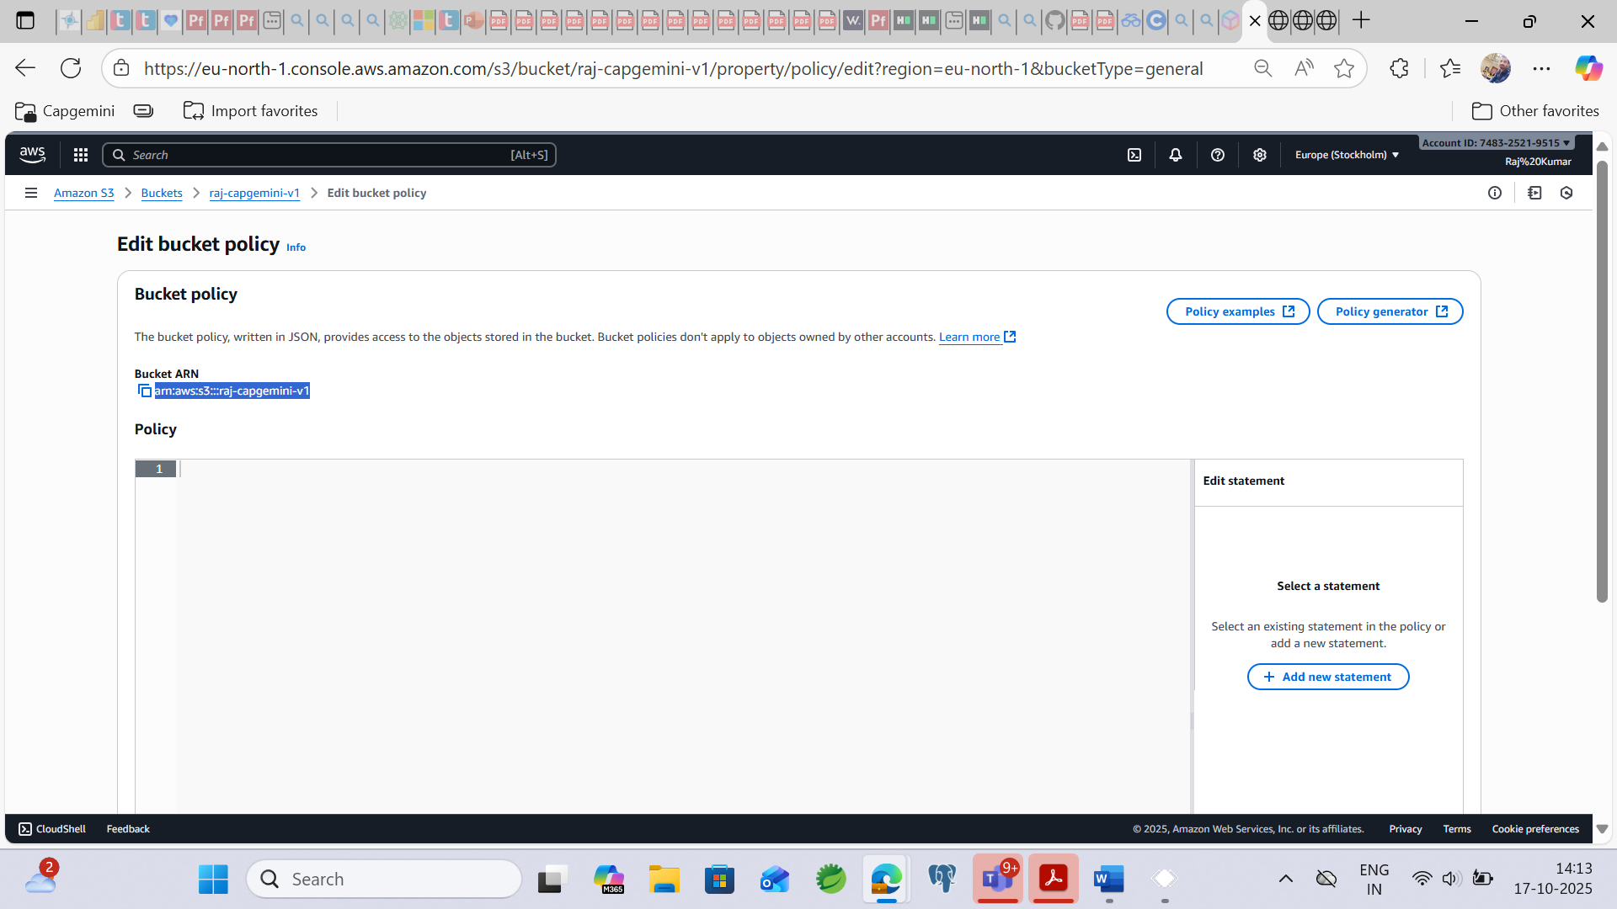  
  
  
**Action – GetObject  
ARN – arn:aws:s3::raj-capgemini-v1  
Then Click on Add Statement**  
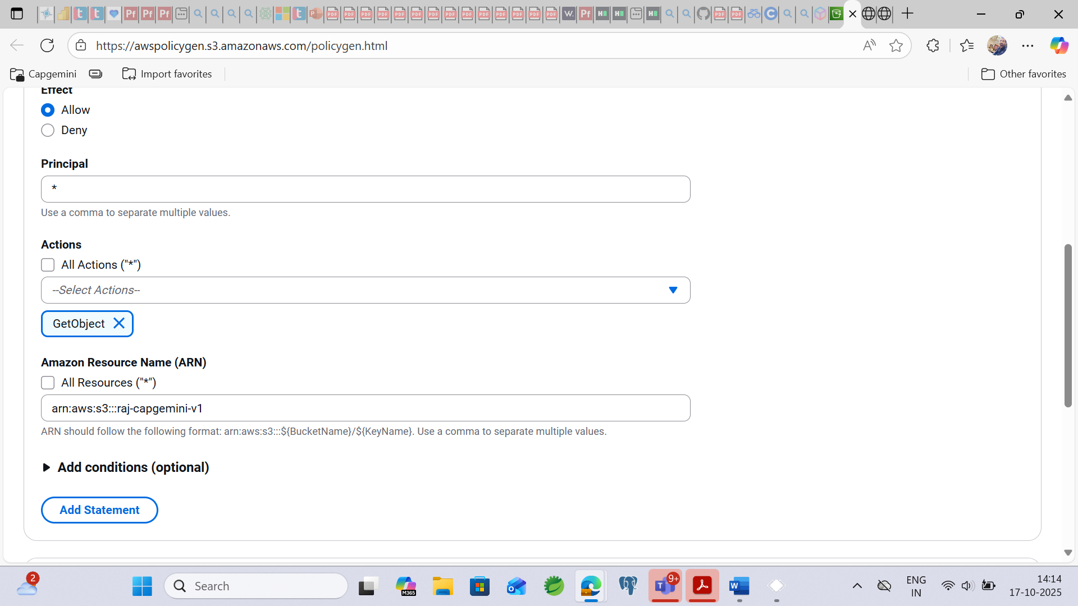

**Step16: After clicking Add Statement, we are getting like this**

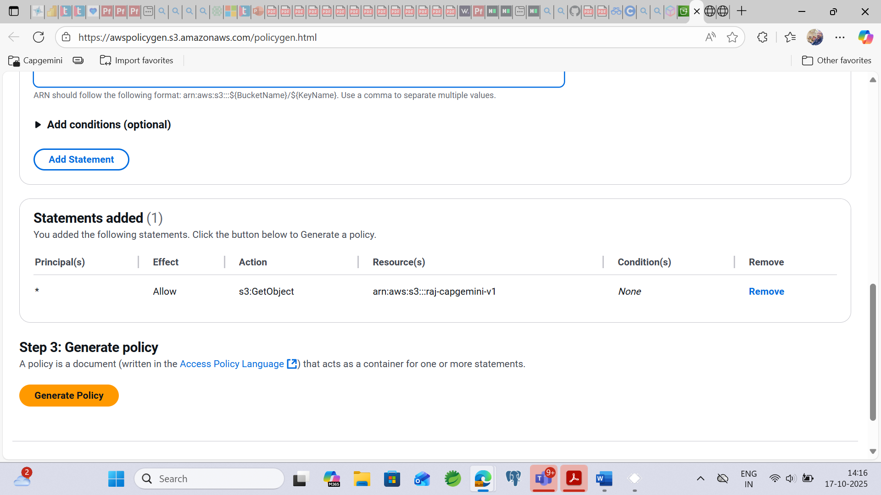

**Step17: Now Click on Generate Policy button And then copy the policy.**  
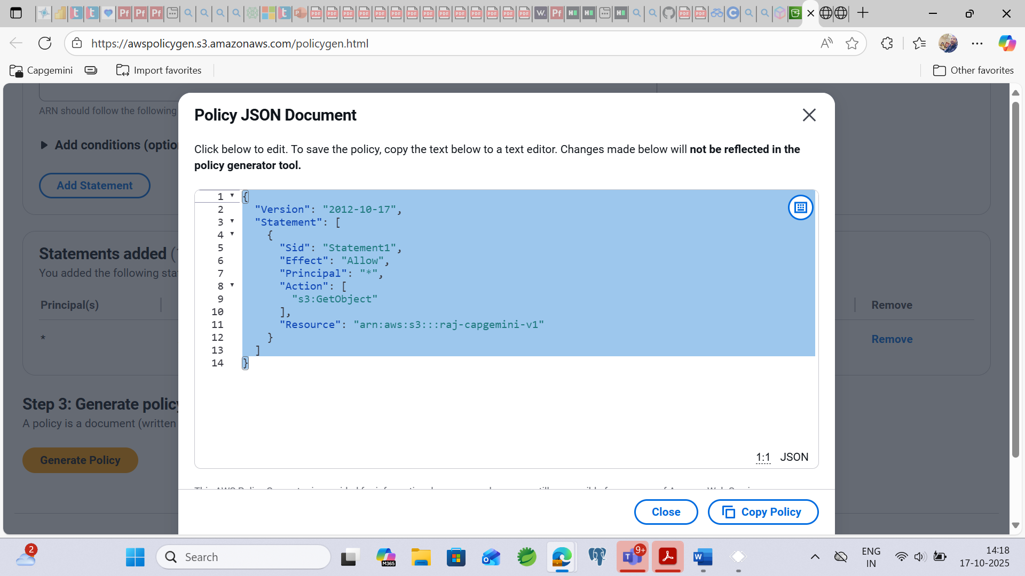  
  
  
  
  
  
**Step18: Paste the copy one policy into Edit bucket policy**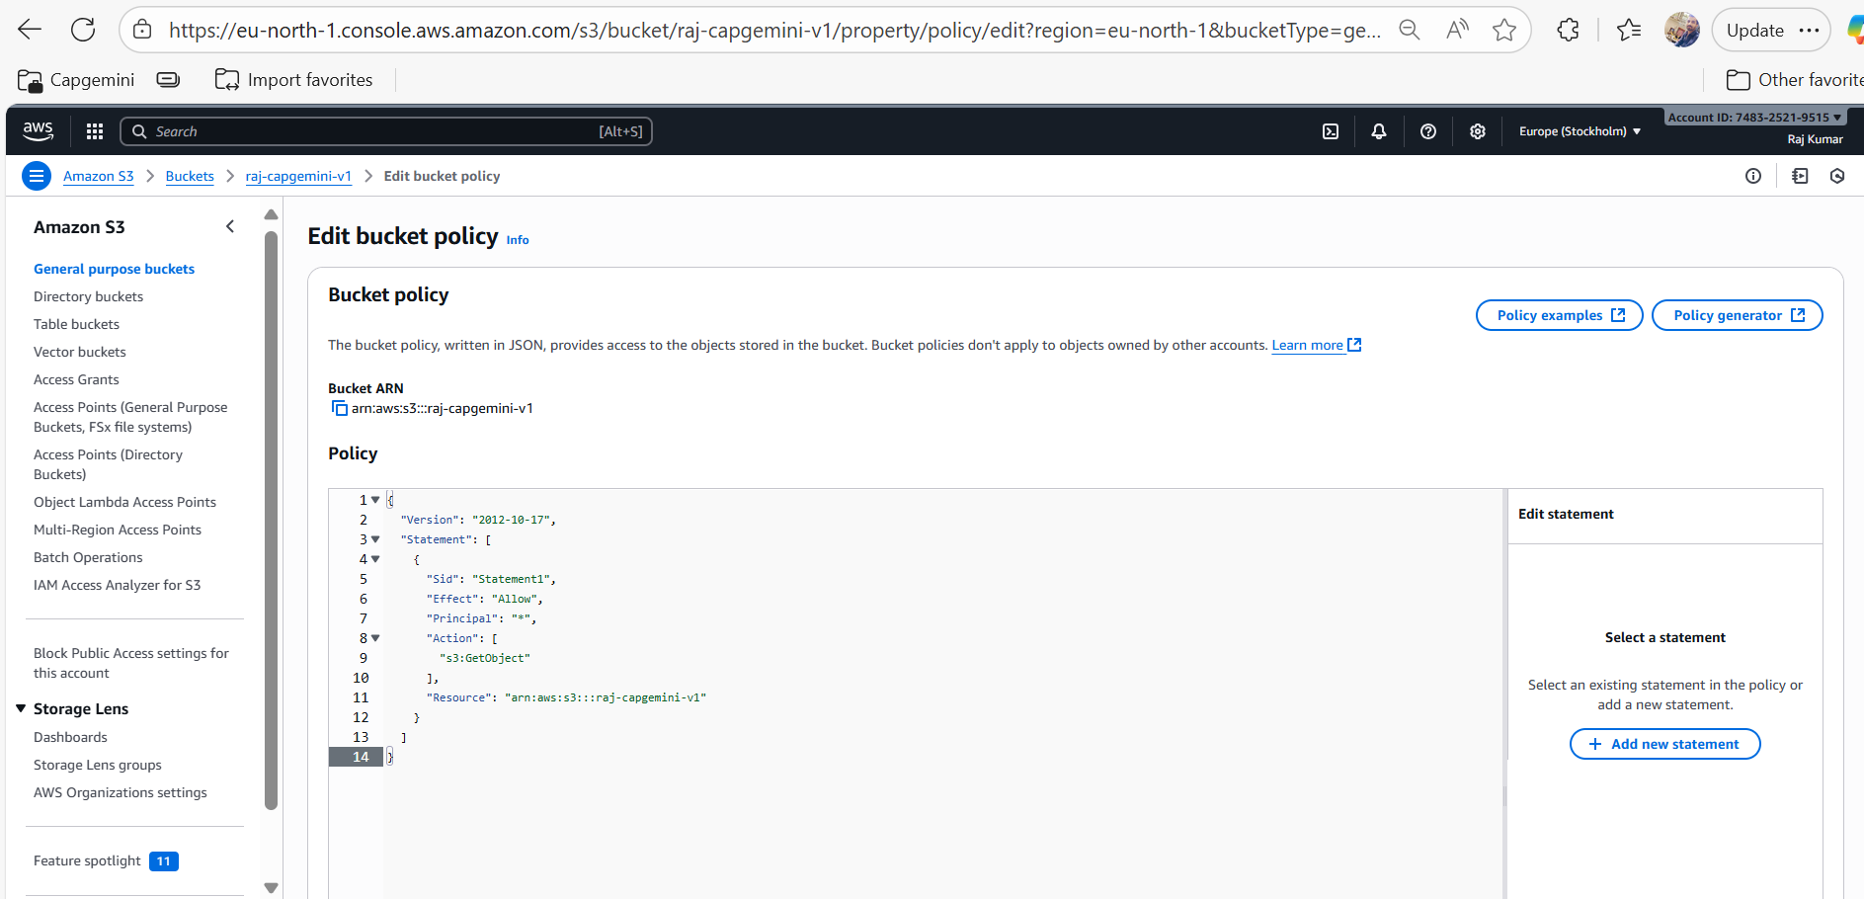

**Step19: Now click on Save changes button, we are getting unexpected error.**

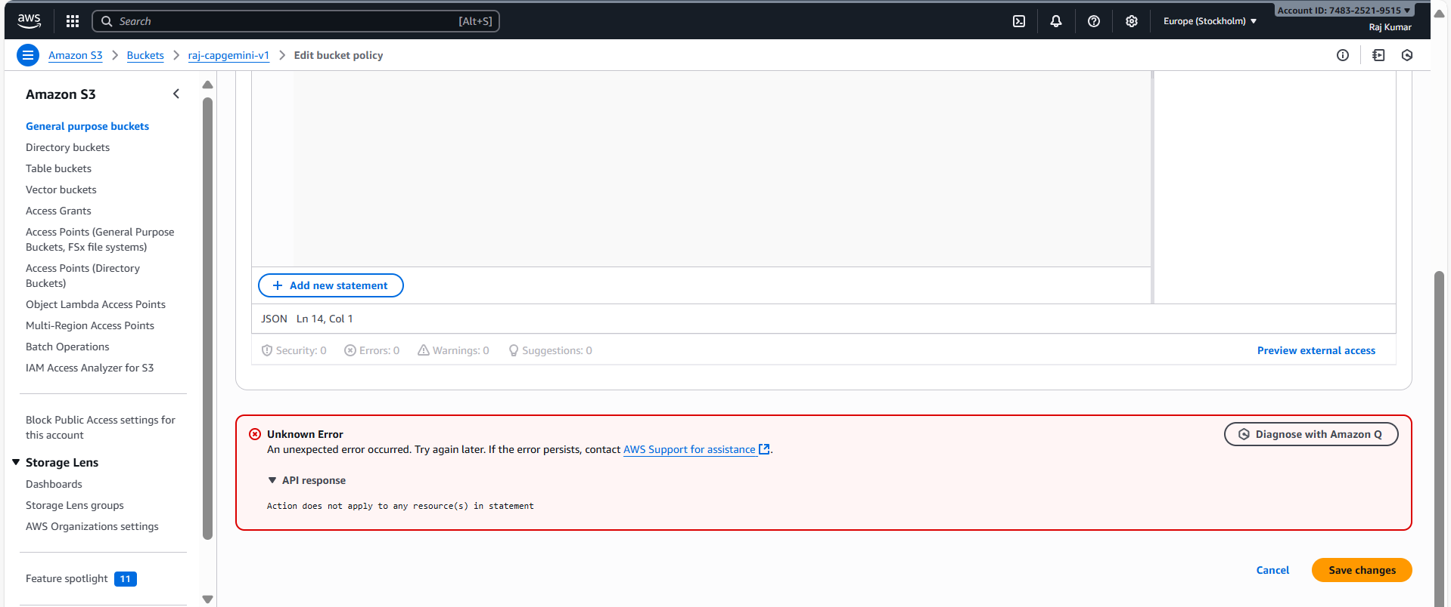

**Step20: Now Adding “/*” for which object we want to assign the policy then click on Save changes button**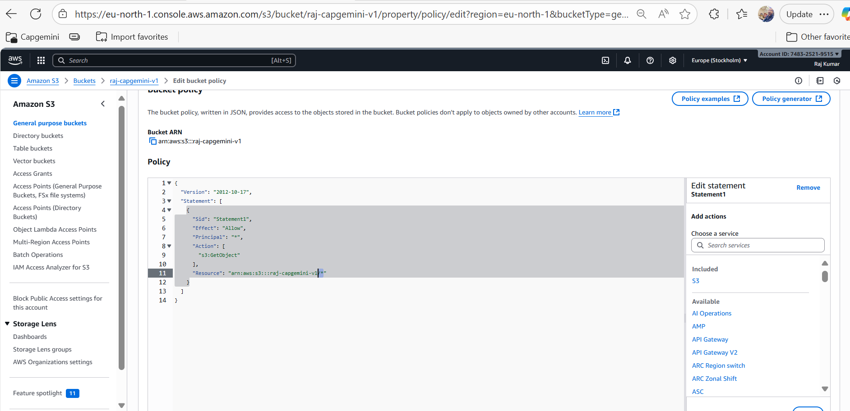

**Step21: Again, we are getting error.**

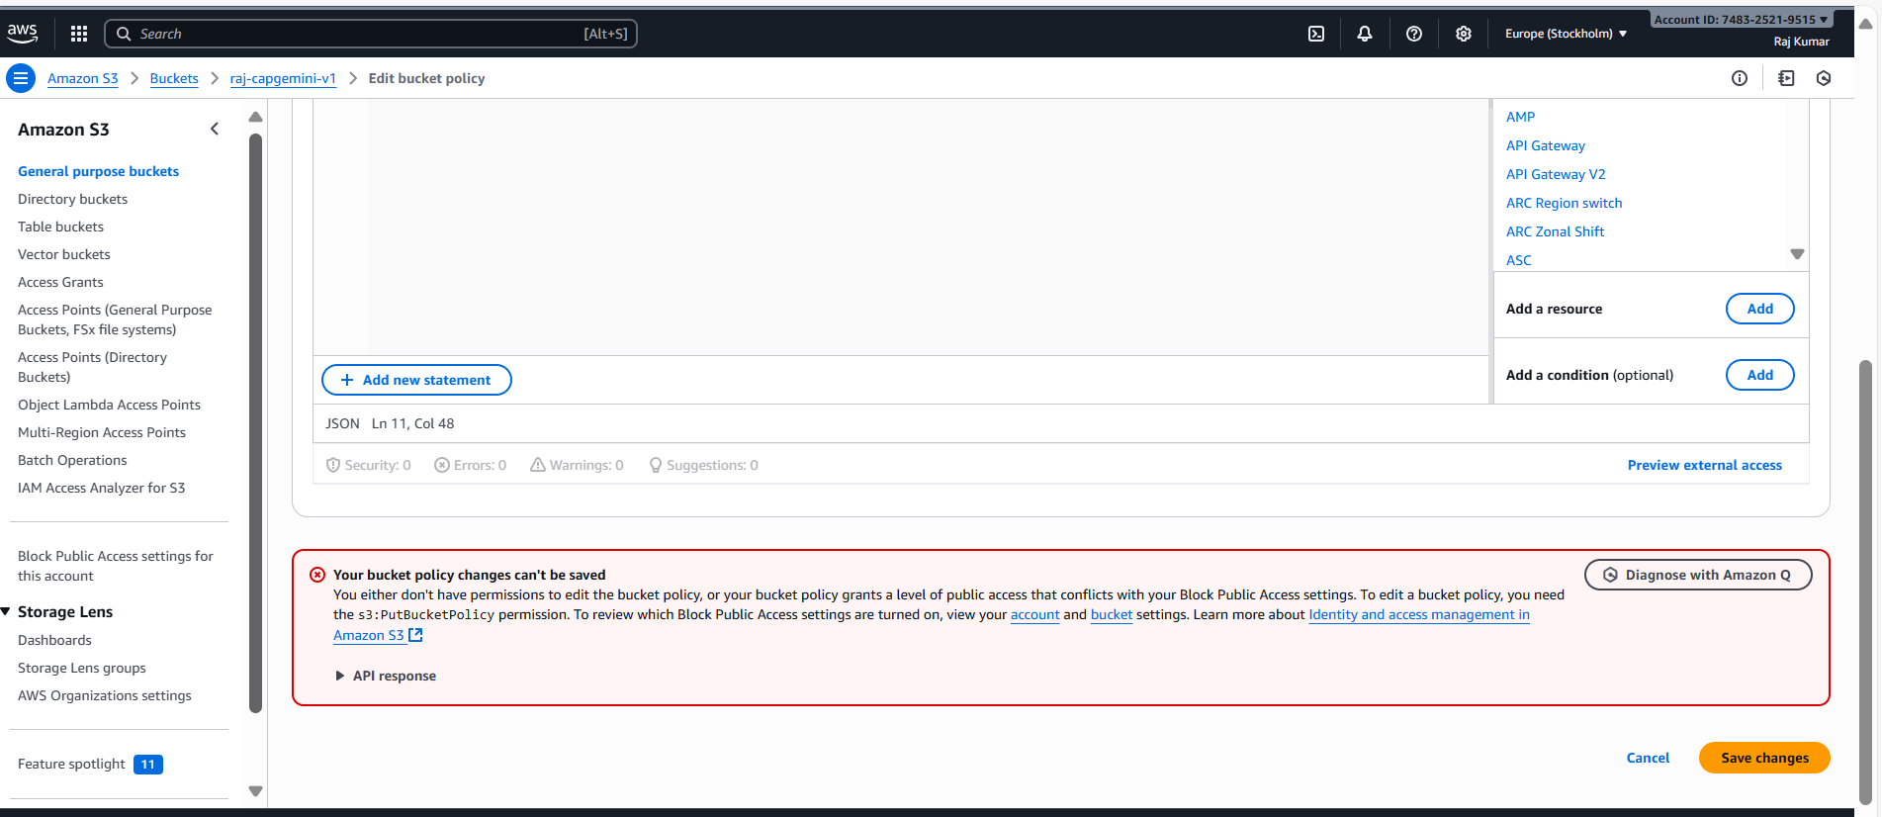  
  
**Reason:** **Bucket we have made as a private that’s why we are unable to save.**

**Step22: Go into your bucket then go under permission then click on edit button.**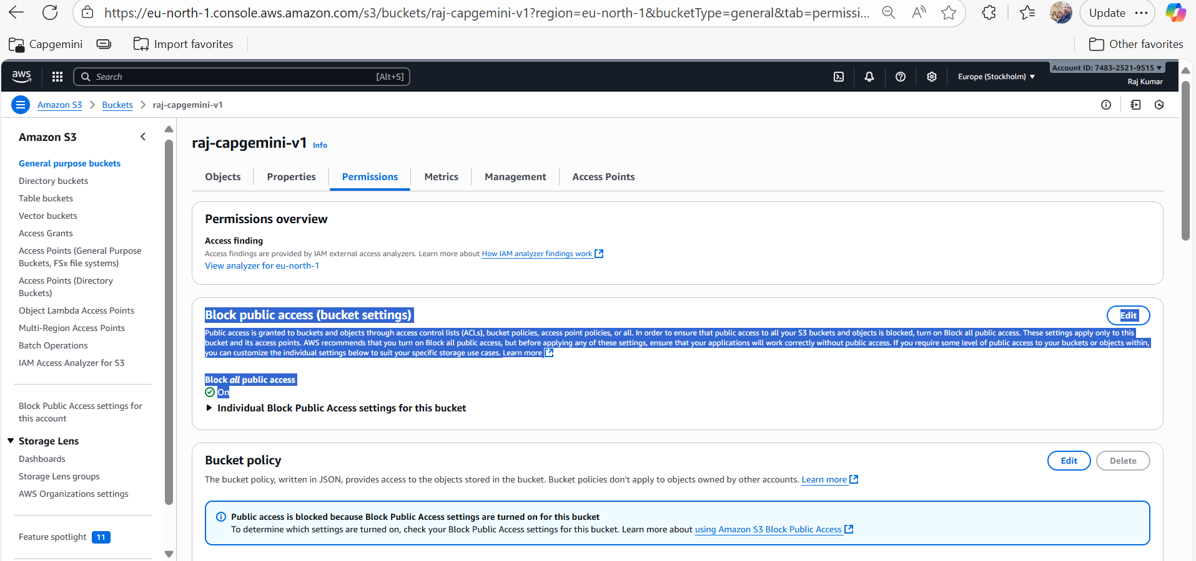

**Step23: Unchecked this checkbox now.**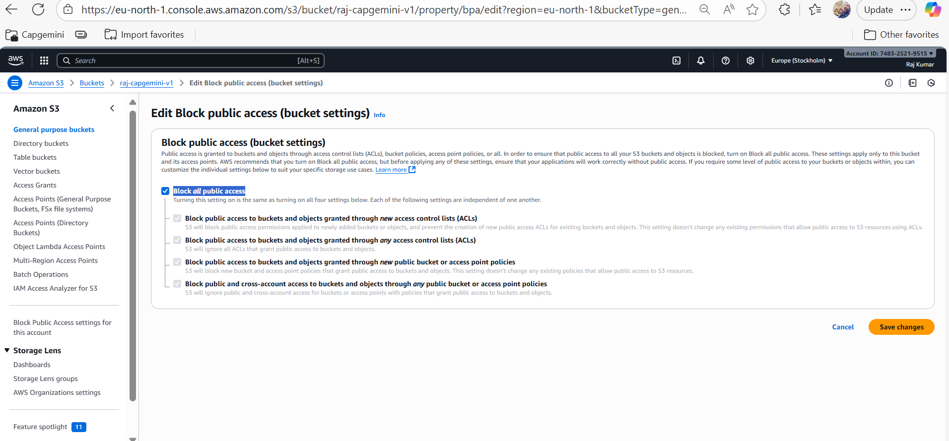

**Step24: After Unchecked, click on Save changes button.**

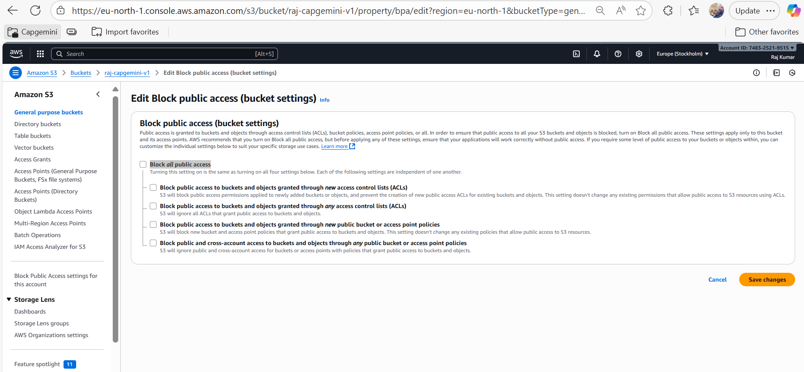

**Step25: Now enter text as confirm and click on Confirm button.**

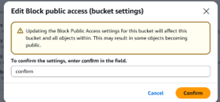

**Step26: Go under Permissions**

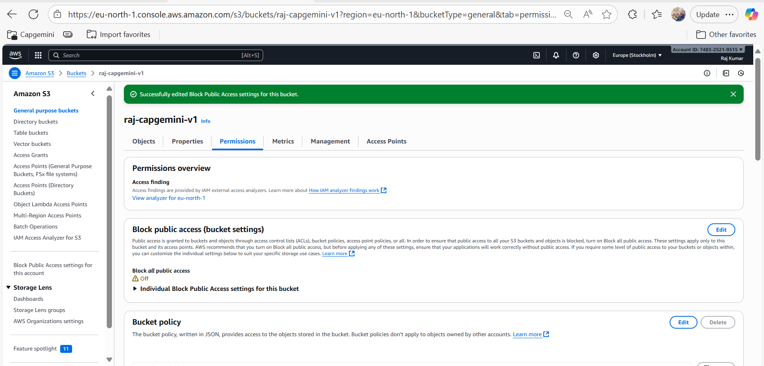

**Step27: Add the same policy here,**

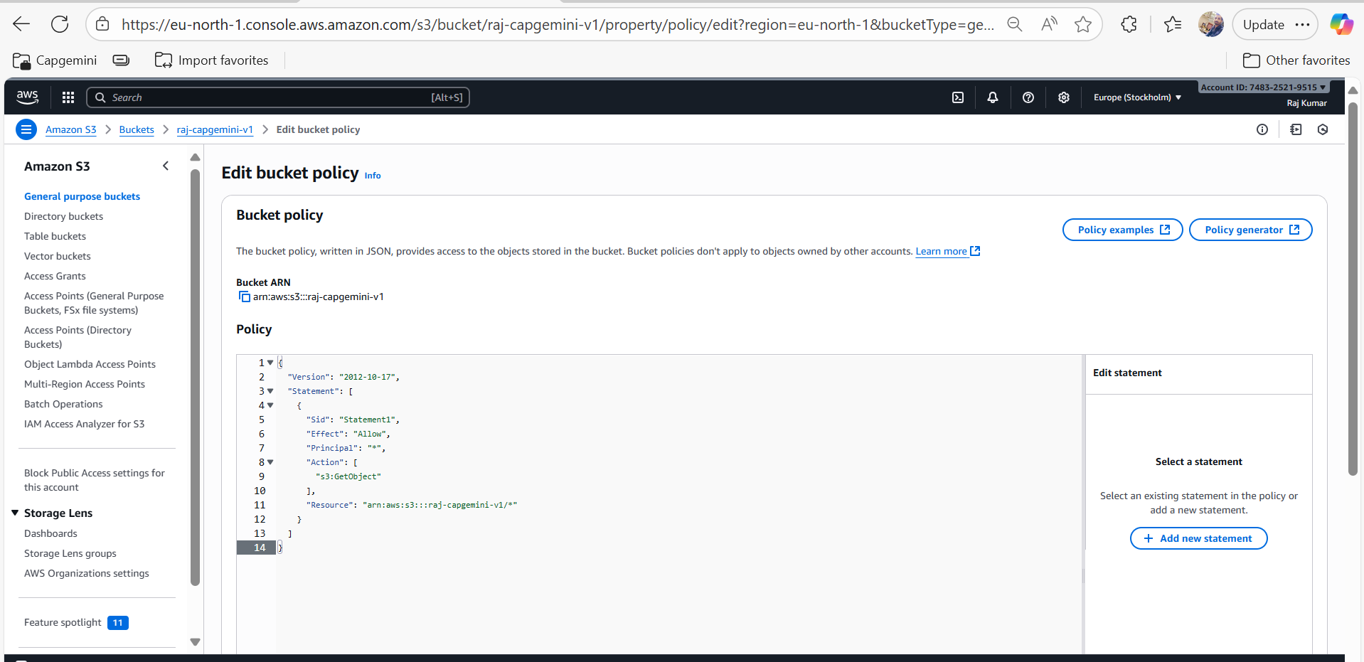

**Step28: Now we are able to edit bucket policy successfully.**  
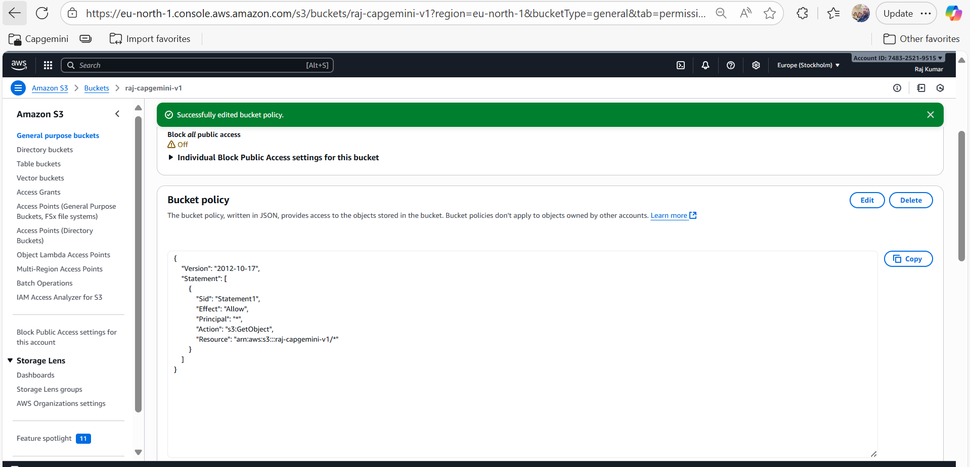

**Step29: We need to go into Objects.**  
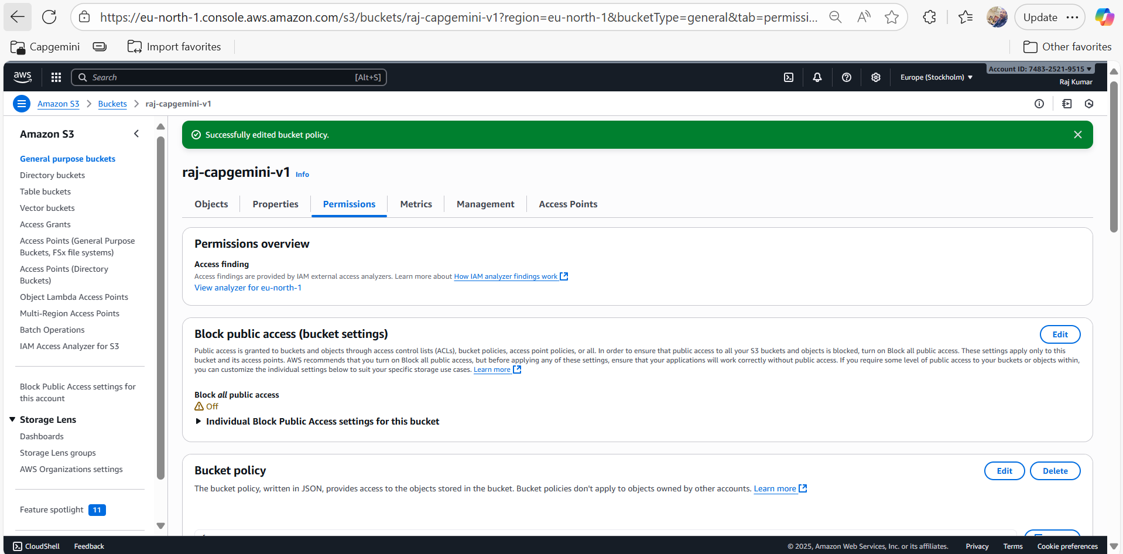

**Step30: Click on image.png file link**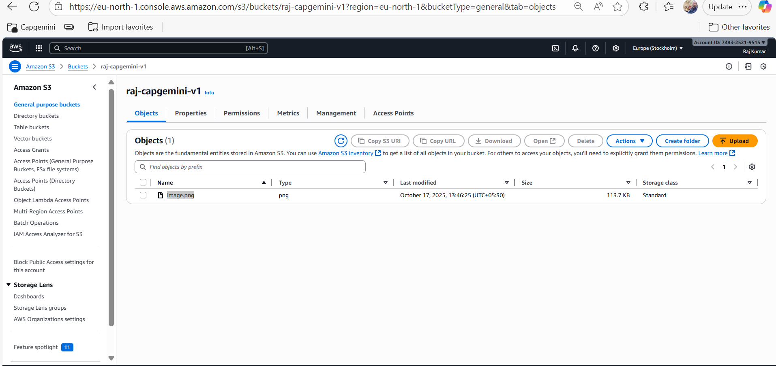

**Step31: Copy the Objects URL now.**  
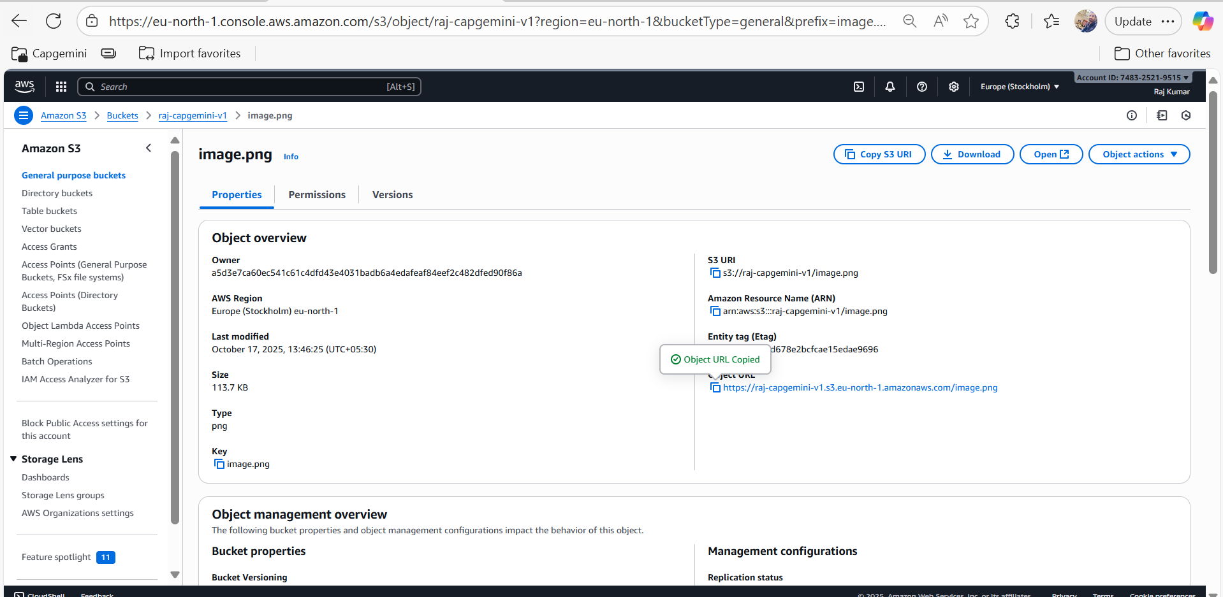

**Step32: Now We are able to access the URL Successfully.**